Home in the Woods
Written and Illustrated by Eliza Wheeler
Penguin, 2019

Book Synopsis: Six-year-old Marvel along with her mother and seven siblings, are homeless after the death of her father during the Great Depression. They move to a deserted tarpaper shack in the woods and, over the course of a year, turn it into a home. Based on the author's grandmother's childhood; includes historical notes.

Lesson
Productive Resources in the Woods
Introduction: It’s not easy feeding a family of nine during the Great Depression. To make it more difficult, they are living in a one room shack in the woods of Wisconsin.
However, they are a resourceful group and manage to apply their skills and tools to use the bounty nature has provided them.

Time: 25-30minutes

Grade Level: 3-5

Materials:
- Visual: Home in the Woods- Productive Resources
- Activity Sheet: Home in the Woods- Productive Resources
- Writing tools

Students Will:
- Review the concept of productive resources.
- Compete an activity sheet based on natural, human, and capital resources.

Virginia Standards of Learning – History and Social Science

2.8 | The student will describe natural resources (water, soil, wood, and coal), human resources (people at work), and capital resources (machines, tools, and buildings).
USII.6 | The student will apply social science skills to understand the social, economic, and technological changes of the early twentieth century by:  d) analyzing the causes of the Great Depression, its impact on Americans, and the major features of Franklin D. Roosevelt’s New Deal.

Procedure:
- Prepare and collect materials prior to class.
- Introduce the lesson telling the students that the story in today’s lesson is based on a book about a family that worked hard to survive during the Great Depression. Explain that the Great Depression took place from 1929 to 1941 when the economy was not working. Banks failed, people were out of work and lost their homes and farms. The Great Depression was worldwide, although it hit the USA the hardest and the longest.
- Read the book Home in the Woods to the students. This takes twelve minutes. If time is a constraint, read the author’s notes at the end of the book and share some of the more compelling illustrations. YouTube reading link: https://www.youtube.com/watch?v=cLblAHx1tLQ
- Display the Visual Activity Sheet: Home in the Woods- Productive Resources with the students and review its content with them.
- Distribute the activity sheet and writing tools. Read the directions to the class. Students may work individually or in pairs.
- Check for understanding. An answer sheet is provided.

Extension:
Challenge the students to think of other productive resources the Banks family used to keep their pantry full and their woodstove operating. Share these examples with the class.

Visual
Home in the Woods- Productive Resources

During the Great Depression, the nine-member Banks family had to use their wits and the resources around them to survive in a one-room shack in the woods in Wisconsin.
By combining the natural resources that the woods provided with their skills and tools they were able to keep their family fed and warm for five years.

Natural Resources – the gifts of nature that are used to produce goods and services including land, timber, fish, oil and mineral deposits.
Human Resources - people working to produce goods and services (farmers, builders, firemen, cooks, doctors, painters, etc.)
Capital Resources - goods made by people and used to produce other goods and services (hammers, computers, trucks, lawn mowers, factory buildings, machines, tools, etc.)

Directions: Fill in the chart with matching natural, human and capital resources.
EXAMPLE:
Natural Resource | Human Resource(s) | Capital Resources
Trout &  Bait | Fishermen-  Marv & Rich | Fishing poles  Fish hooks  Bucket

Activity Sheet-
Home in the Woods- Productive Resources
Natural Resources – the gifts of nature that are used to produce goods and services including land, timber, fish, oil, and mineral deposits.
Human Resources - people working to produce goods and services (farmers, builders, firemen, cooks, doctors, painters, etc.)
Capital Resources - goods made by people and used to produce other goods and services (hammers, computers, trucks, lawn mowers, factory buildings, machines, tools, etc.)
Directions: Using the provided words, fill in the chart so that the rows reflect the matching natural, human, and capital resources experienced by the Banks family while they lived in the home in the woods.

Natural Resource | Human Resource(s) | Capital Resources
Word Bank
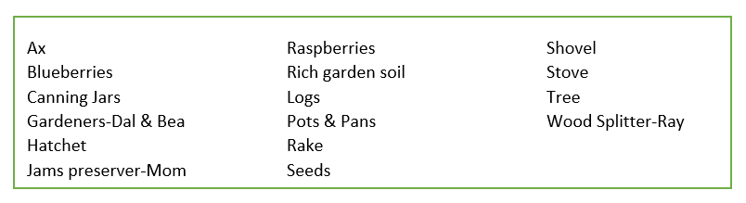

Possible Answers

Natural Resources – the gifts of nature that are used to produce goods and services including land, timber, fish, oil and mineral deposits.
Human Resources - people working to produce goods and services (farmers, builders, firemen, cooks, doctors, painters, etc.)
Capital Resources - goods made by people and used to produce other goods and services (hammers, computers, trucks, lawn mowers, factory buildings, machines, tools, etc.)

Natural Resource | Human Resource(s) | Capital Resources
Blueberries  Raspberries | Jam preserver-  Mom | Stove  Pots & Pans  Canning Jars
Seeds  Rich garden soil | Gardeners -  Dal & Bea | Shovel  Rake
Trees  Logs | Wood spitter- Ray | Ax  Hatchet
Word Bank
