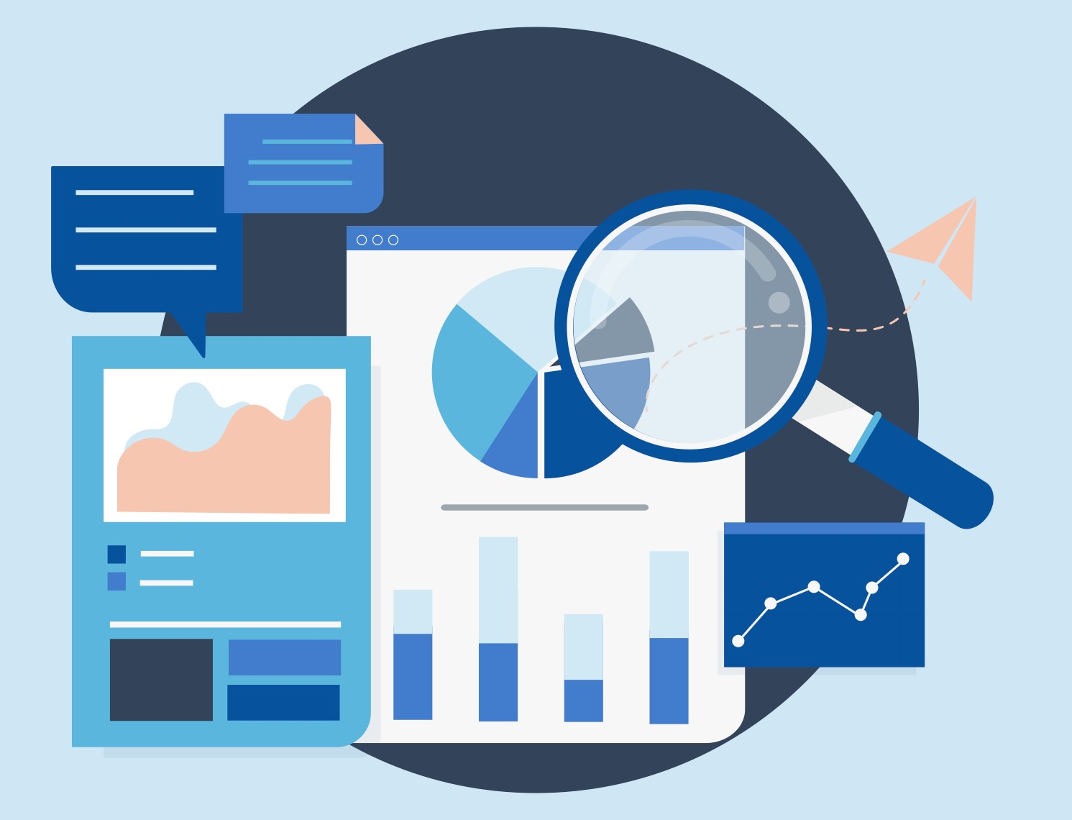

Lesson 2:

Can You Conduct Research Ethically?
Author: Matt Pierson

In this economics lesson, students will learn about positive and normative economics and how bias in questioning can lead to ethical issues in research.

Description of the lesson
In this lesson, students will learn how their bias impacts their decision-making and research. Students will be faced with some classic visual riddles and then try to answer a guiding question about the United States with limited data. They will learn the difference between positive and normative economics in a short worksheet. Then students apply their knowledge of economic research to create their own research statements and answer questions about how economics must use ethics in their research.

Teacher note: This lesson uses HyperDocs and requires that students have computer and internet access. The lesson can be completed without students having devices. Once you get to procedure 5, use the alternative method and display the HyperDocs one at a time to the whole group.

Economics
In economics, research is conducted about a variety of topics. Positive economics are factual economic statements backed up by data. Normative economics are value statements about how something ought to be. This lesson shows the difference between positive and normative statements and how both of those terms play a large role in research and the results. Overall economists rely on sound research and responsible practices to form policy recommendations and create economic reports about different populations or geographic locations.

Ethics
Researchers are expected to conduct themselves ethically when collecting and analyzing data. This means being aware of implicit biases to limit the impact of bias in their questioning and in their analysis of results. Ethical research does not eliminate bias and preconceived notions, but it limits them and recognizes them so that the researcher can reach the best conclusion possible. Additionally, researchers are expected to tell the truth about their findings, not falsify or withhold them. Ethics contributes to the scientific process.

Objectives:
After completing this lesson students will be able to:
- explain the difference between positive and normative economics.
- create research statements that use limited bias in questioning to collect data on an economic issue.

Standards
Voluntary National Content Standards in Economics

- Standard 2: Decision Making
  - Effective decision making requires comparing the additional costs of alternatives with the additional benefits. Many choices involve doing a little more or a little less of something: few choices are “all or nothing” decisions.

Concepts
Decision Making, positive and normative economics

Time Required
60 Minutes (Assessment can be done outside of class time)

Materials Needed
- Presentation Slides: How can you conduct research ethically?
- Computers with internet access, at least one per group of 3-4 students
- PDF HyperDoc copy of Visual 2A: How Powerful is the United States?
- PDF HyperDoc copy Visual 2B: How Powerful is the United States?
- Pencil/Pen, one per student
- Copies of Activity 2.1: Positive vs. Normative Economics, one per student
- Copies of Assessment 2.1: Creating Your Own Research Statements

Preparation
This lesson includes documents that are HyperDocs - each HyperDoc is a PDF. When you click on each image on the PDF, you get a full version of the image and a further breakdown of the data included. You will need to distribute them electronically so that students can click on each graph or map to enlarge them and receive more detail. If you are one to one with technology or computers or electronic devices, then email half the students Visual 2A and then email the other half of students Visual 2B. If you are not one to one, have each group designate a group leader with a device and email the document to each group leader, making sure that half the groups get Visual 2A and half get Visual 2B

Procedure
- Begin the lesson by telling your students they will be learning how economists conduct research. First, start by asking students “What is research?" Answers may vary but include: studying something, finding or creating something new, reading, etc. Tell students that research is something that many professions must do to learn or create new knowledge. Economists in particular do research to learn new things on a variety of topics like production, sports, education, and more.

- Next, ask “What does it mean to be ethical? Answers may vary but include: doing the right thing, being honest, not hurting anyone, etc.
- Show slide 1 of the presentation slides: Can you conduct research ethically?
  - Ask the students “Is it important that people who are doing research behave ethically?” Answers may vary but include: Yes, because they should not lie about results or they need to be honest and trustworthy.
  - Explain to students that how you ask questions and how you interpret data can impact how you see and analyze results of research. Make special note that economics is the study of choices and so when economists do research, they are learning something new about people and therefore must be even more ethical as often the subjects of their research are people.
- Display slide 2 which shows a classic illustration and visual riddle. To some students it will look like a duck, to others it will look like a rabbit. Ask the students what they see. After a few shout out their answers, ask the students to raise their hand if they saw a rabbit, then the same if they saw a duck. Next ask the following questions which are on Slide 3.
  - Have you seen this photo before? Answers will vary but many will say yes.
  - For those who have seen it before, Did this impact your answer to the question? Answers will vary but may include: yes, because I already knew it was a duck/rabbit. They might already know that it was a trick question.
  - Can you think of any other pictures like this? Answers will vary but may include: the old woman or young woman that will be featured on a future slide.
- Next show the students the image of another classic visual riddle of the old woman or young woman on slide 4. Ask the students what they see. After some have shouted out answers, ask students who see an Old Woman to raise their hand, then ask the same for students who see a Young Woman. Ask the students the following questions:
  - How can they be looking at the exact same picture but seeing different things? Answers may vary but include: our minds all work differently; experiences can shape the way we look at pictures or other things.
  - Follow this up by asking students if they have ever experienced a situation where they and a friend or other person interpreted what happened differently even though they saw or experienced the exact same thing? Answers will vary but students might mention examples from sports or games when a person would have made a different move/play, students could talk about having different interpretations of books, poems, or movies, if a natural disaster happens some students might have more fear or different experiences than others, etc.
- Divide the class into groups of 3-4. Next, ask the students if they think the United States is powerful. Answers may vary but many students will say yes. Follow up by asking why they think that? Answers may vary but include: the US is wealthy or has a lot of money, strong military presence around the world, we have a lot of resources.
- Distribute “Visual 2A: How Powerful is the United States?” to half the groups and “Visual 2B: How Powerful is the United States?” to the other half of the groups. When the students access their document, have them come up with a group consensus on if the United States is powerful or not using ONLY the data given to them on their HyperDoc. All students in the group should have the same HyperDoc. Do not let the groups discuss with other groups since some groups will have a different data set. Give them five minutes to look at the visuals and come up with their group answer. Make sure that each group assigns a leader that will explain their answer to the group. Instructions are on slide 5. If the HyperDoc is not a possibility for your classroom, the PDFs can be printed, or each graph is provided in the References Section of this lesson.
  - Teacher Note: Visual 2A includes a graph showing GDP (Gross Domestic Product), a graph that shows global military spending, a graph that shows alternative energy investment, and a graph that shows internet speeds. All the graphs in Visual 2A should lean towards the United States being a powerful nation.
  - In Visual 2B there is a graph showing the world happiness rankings, a graph showing global corruption rankings, one showing health care costs, and one showing women in politics. The graphs in Visual 2B should lean towards the United States not being as powerful as one might assume. The data and graphs update based on the latest information to the websites so while the images on the PDF will not change (unless you edit them) the links the students will go to will be updated.
- Ask the following questions to the students. You will want to bring attention to the fact that certain groups have different answers than other groups.
  - Is the United States Powerful? Answers may vary but students with Visual 2A will say that the US is powerful based on GDP (the total monetary or market value of all the finished goods and services produced within a country’s borders in a specific time period), Military, Green Energy, and Internet Speeds. Students with Visual 2B will say the United States is not powerful based on Happiness, Corruption, Health Care, and Women in Power.
  - Ask the students, why were their answers different? Answers may vary but include statements about how people interpret things differently.
  - What data did they use to answer the question? Answers may vary but include the topics listed on the HyperDocs.
- Once they have had time to think and you have gotten a few responses, explain to them that there were 2 different sets of data, and both were from reputable resources. Then explain that the data was selected to invoke a different response from the groups to a question that they believed had an obvious answer.
- Make both Visual 2A: How Powerful is the United States? and Visual 2B: How Powerful is the United States? available to the students either via email or through your district learning management system (LMS). Ask them individually to look at the document they were not given in their group. Give them about three minutes to look over the opposing data. Again, if students do not have a device, the PDF is printable and the links to the graphs are in the References Section.
- Ask the following questions to the students (provided in slide 9):
  - Now that you have seen both data sets, how would you answer the question, “Is the United States Powerful?” Answers will vary but include: they will probably say that they would have answered the questions differently. Bring out the key point that different perceptions affect research.
  - Does seeing the other data change your answer? Answers will be yes or no
  - If this data is credible, how could your answers have been so different? Answers may vary but include: that when you only look at small sections of data you get different results than if you look at full data sets. Point out that students' preconceived notions also change how they interpret the data, just like it changed how they interpreted the photos from the beginning of class.

- Slide 10: Have students return to their regular seats. Explain to students there are some vocabulary terms that you will need to understand about conducting research. These vocabulary terms are listed and defined below and on slide 10. Define the following terms for students
  - Economic model: a simplified picture of reality which hypothesizes causality between variables in order to predict or understand outcomes
  - Facts: knowledge about the world
  - Fiduciary duty: the obligation of one party to another party; a situation in which trust is expected
  - Ideology: a framework of beliefs or theories about the world
  - Moral hazard: a situation in which one party to a transaction has both an incentive and the ability to extract unearned rewards from another party or behave unethically
  - Values: principles or beliefs that guide behavior and choice
- Slide 11: Explain that an economic model is like a road map focusing on the larger roads/interstates–it guides how a researcher would look at a subject they are studying and the big ideas the economist is interested in researching. Researchers gather facts from sources including data, surveys, etc.
- Slide 12: Continue by explaining that how we perceive an outside reality is partly a function of our inside mental activity and values. Thus, ideology and our acquaintance with prior random information can bias the identification and collection of what we call “facts.” Investigators often “see” what their prescientific vision leads them to expect to see and ignore information that contradicts their preconceptions.
  - Next, explain that researchers hold a lot of responsibility. Ask the students what would happen if researchers behaved unethically, lied about their work or results? Answers may vary but include: it would be hard to believe anything that they said or wrote, people would not trust economists or other researchers, etc.
- Slide 13: Follow this up with a statement that researchers carry a lot of responsibility, and they are charged with maintaining high ethical and honesty standards and must fulfill their Fiduciary duty. Define the term as the obligation of one party to another party; a situation in which trust is expected. Then provide the example that doctors must fulfill their fiduciary responsibility by taking care of their patients and not talking about their private information. Ask the students the following questions:

  - What sort of fiduciary duties might an economist or researcher have? Answers may vary but include researchers cannot lie or change the data, researchers might know a lot of personal information like income, opinions, health information, etc. and it’s their job not to tell anyone or disclose this information in any way, they must maintain complete confidentiality of the people participating in the research, etc.
  - What are the obligations of someone doing research to make sure that all sides/ideas are represented? Answers may vary but include using information from multiple sources, interviewing or asking questions to different people, reporting all results not results that fit your story, recognizing bias, asking questions that are open ended, and reporting data accurately.
- Explain to students what positive and normative economics are; the definitions are on slide 14. Tell students that positive economics are factual statements about economics that can be backed up by data whereas normative economics are value statements that explain how the researcher believes things should be like in an economy.
- Give each student a copy of Activity 2.1: Positive vs Normative Economics. In their pairs, have them decide if each statement is a positive or normative economic statement and answer the final question. Give students about 3 minutes to work through this. Go over the answers using Slide 15 as a class after discussion has ended or after about 3 minutes.
  - The unemployment rate for the United States is 4.8%. P
  - The United States should offer paid parental leave. N
  - The President of the United States should increase spending in the economy to help with the crisis. N
  - The United States has a GDP of $20.48 trillion dollars P
  - Businesses should pay a living wage to their employees. N
  - The United States runs a trade deficit. P
  - People in the United States should buy American made products. N

Closure
- Slide 16: Review the ways in which scientific research requires ethical choices. Ask the students what ethical behaviors are required of researchers for scientific research to be effective. Answers may vary but include: Researchers should be aware that everyone approaches problems from a particular worldview and that this creates possible sources of inspiration but also of bias. Researchers should therefore strive to be as impartial as possible when they do positive economic analysis and to obey absolute moral standards of behavior regarding honesty, integrity, fair-mindedness, and intellectual autonomy.
- Debrief the lesson by explaining that economists and researchers must behave ethically. There are serious consequences if people could not or would not trust the information from research. Researchers also are among professionals who face a fiduciary duty. They must maintain ethical standards and protect the people that are part of their study.

Assessment
- Hand out copies of Assessment 2: Creating Your Own Research Statements to each of the students. Have them work on the assessment in class or as homework. If assigning as homework, make sure students have access to the HyperDocs. Use Assessment 2: Creating Your Own Research Statements (Suggested Answers) to help with the discussion.
Some sample assessment items:

- Researchers in economics
  - face ethical issues only in normative economics.
  - face ethical issues only in positive economics.
  - face ethical issues in both positive and normative economics.
  - face no ethical issues because economics is a science.
- An accountant does not share how much income her client makes in a year with their family or friends. This is an example of which term?
  - Fiduciary Duty
  - Moral Hazard
  - Economic Model
  - Positive Economics
- Which of the following is a positive statement?
  - The United States is ranked in the top 50% for wealth in the world.
  - The United States is the best country to live in.
  - The United States should prevent more crime in other countries.
  - The United States should run a trade surplus.
Essay
- How do ethics play a role in research in economics? Answers may vary but include: researchers have to control and identify their biases in questioning and analysis but also attempt to conduct positive economic research while using normative economics to give value judgments.

Extension

References
Ang, C., Desjardins, J., & Routley, N. (2021, September 29). Mapped: The Fastest (and Slowest) Internet Speeds in the World. Visual Capitalist. Retrieved July 25, 2022, from https://www.visualcapitalist.com/mapped-the-fastest-and-slowest-internet-speeds-in-the-world/

Bhutada, G., Conte, N., & Lu, M. (2022, February 7). Ranked: The Top 10 Countries by Energy Transition Investment. Visual Capitalist. Retrieved July 25, 2022, from https://www.visualcapitalist.com/ranked-the-top-10-countries-by-energy-transition-investment/

Desjardins, J., & Ang, C. (2017, March 31). The U.S. Spends More Public Money on Healthcare Than Sweden or Canada. Visual Capitalist. Retrieved July 25, 2022, from https://www.visualcapitalist.com/u-s-spends-public-money-healthcare-sweden-canada/

Ghosh, I., Ang, C., & Routley, N. (2021, March 8). Mapped: Where Women Hold the Most and Least Political Power. Visual Capitalist. Retrieved July 25, 2022, from https://www.visualcapitalist.com/mapped-where-women-hold-the-most-and-least-political-power/

Ghosh, I., Wallach, O., & Lu, M. (2021, June 27). Mapped: Happiness Levels Around the World in 2021. Visual Capitalist. Retrieved July 25, 2022, from https://www.visualcapitalist.com/mapped-global-happiness-levels-in-2021/

Neufeld, D., Lu, M., & Ang, C. (2021, December 22). Visualizing the $94 Trillion World Economy in One Chart. Visual Capitalist. Retrieved July 25, 2022, from https://www.visualcapitalist.com/visualizing-the-94-trillion-world-economy-in-one-chart/

Routley, N., Ali, A., & Ang, C. (2021, July 30). Visualizing U.S. Military Spending vs. Other Top Countries. Visual Capitalist. Retrieved July 25, 2022, from https://www.visualcapitalist.com/u-s-military-spending-vs-other-top-countries/

Wallach, O., & Ang, C. (2022, February 11). Mapped: Corruption in Countries Around the World. Visual Capitalist. Retrieved July 25, 2022, from https://www.visualcapitalist.com/mapped-corruption-in-countries-around-the-world/

Visual 2A. How Powerful is the United States?
HyperDoc 1: Note that this is an image of the HyperDoc that you will need to send out to students and does not have links to the sources in this image.
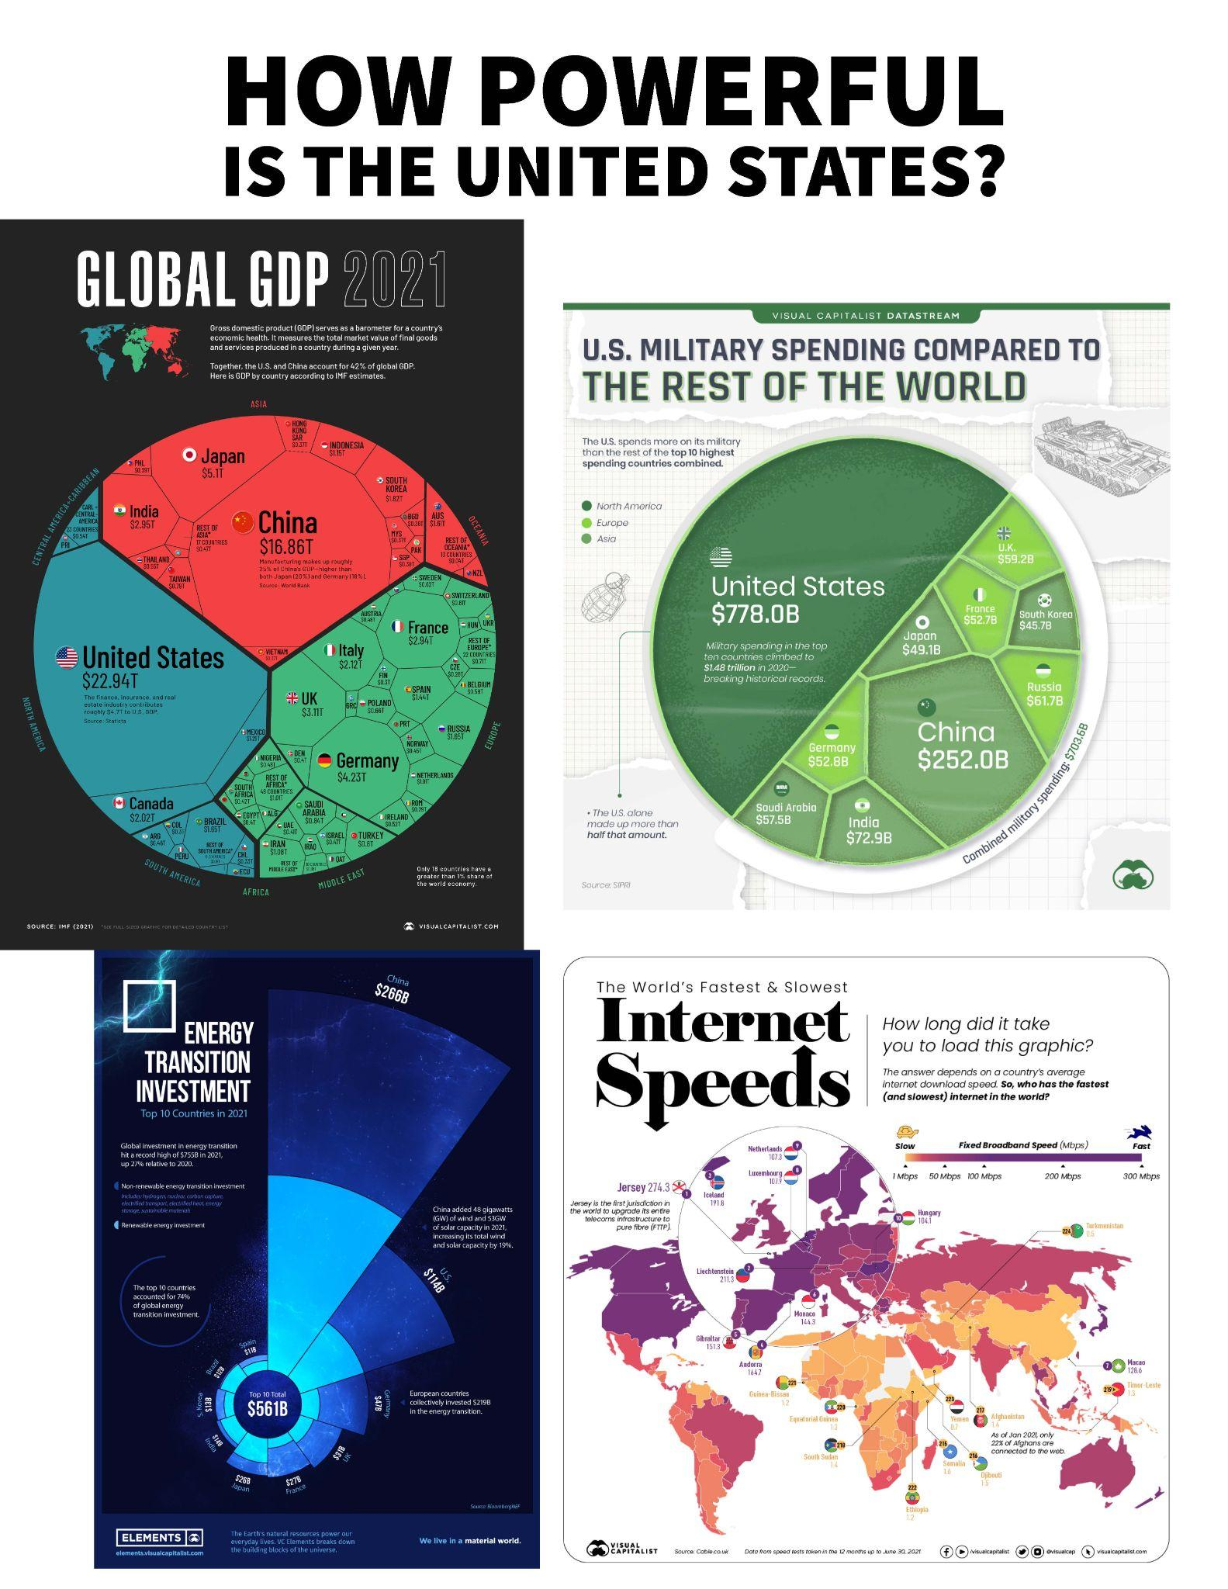

Visual 2B How Powerful is the United States?
HyperDoc 2: Note that this is an image of the HyperDoc that you will need to send out to students and does not have links to the sources in this image.
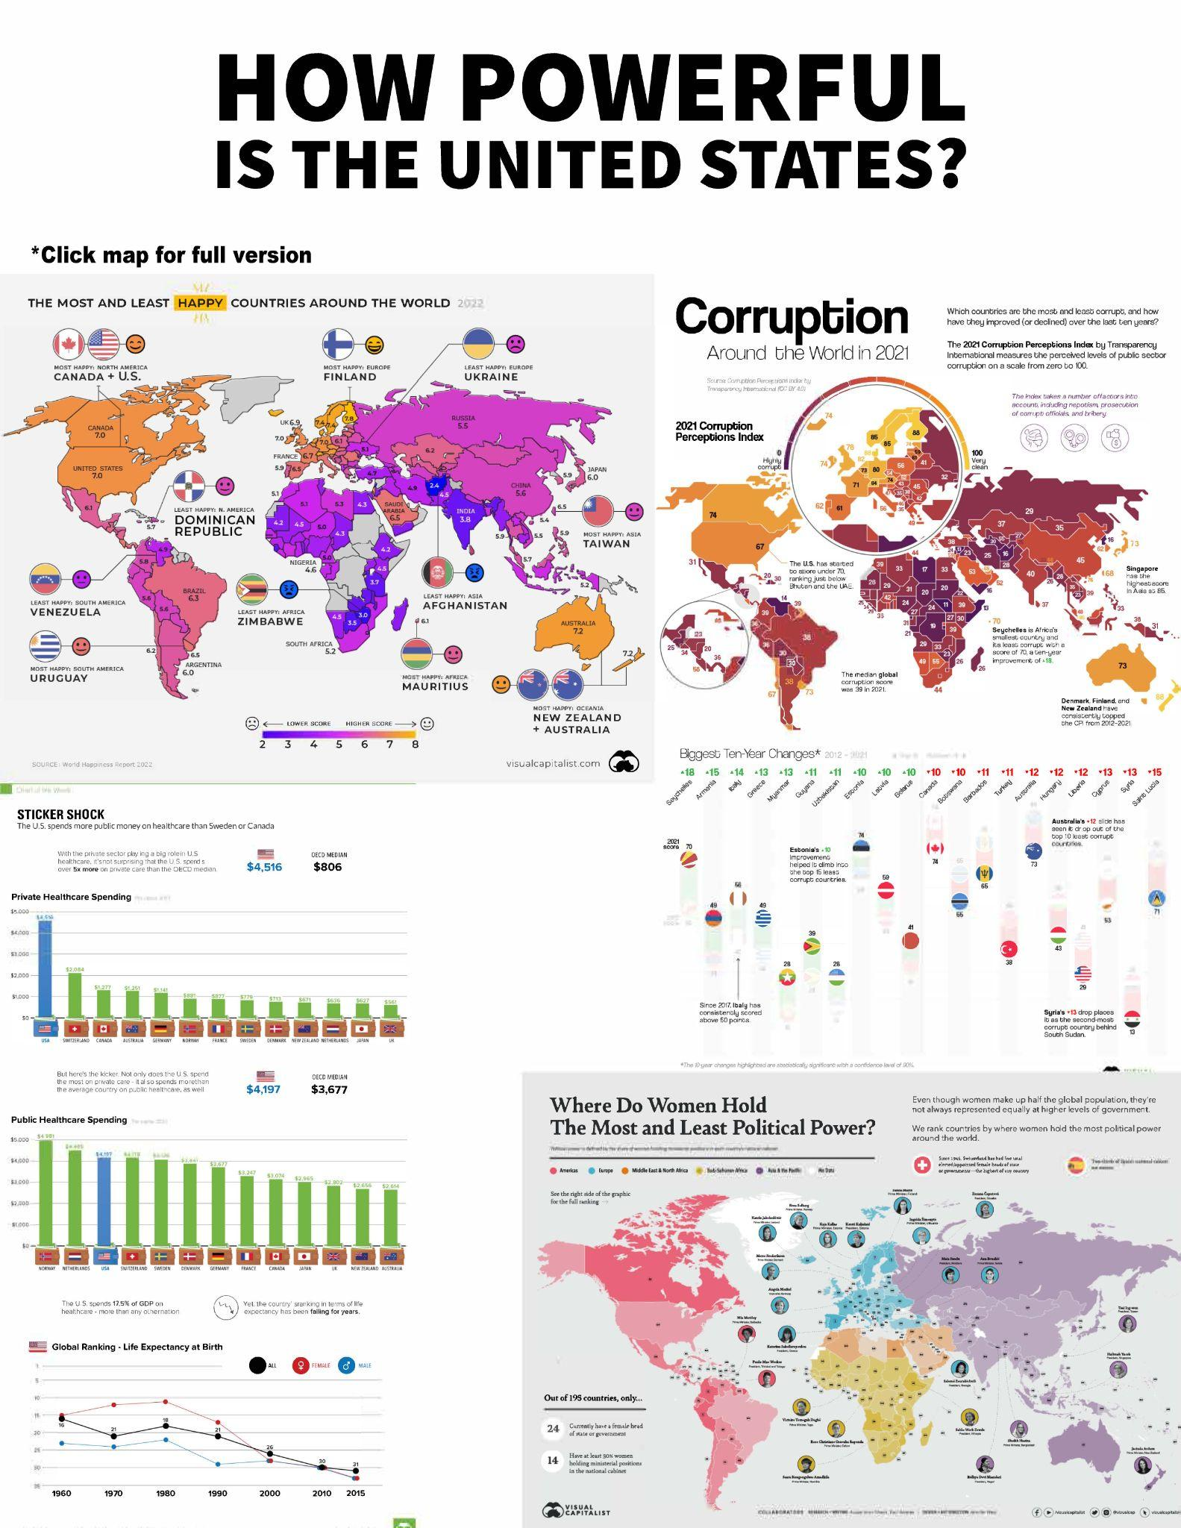

Activity 2.1: Positive vs. Normative Economics

Directions: For each statement below, put a “P” next to statements that are examples of positive economics and a “N” next to statements that are examples of normative economics.

- The unemployment rate for the United States is 4.8%.

- The United States should offer paid parental leave for its mothers.

- The President of the United States should increase spending in the economy to help
with the crisis.

- The United States has a GDP of 20.48 trillion Dollars

- Businesses should pay a living wage to their employees.

- The United States runs a trade deficit.

- People in the United States should buy American made products.

Assessment 2.1: Creating Your Own Research Statements
- What role do positive and normative economics play? Why might you use each one as an economist?

- Provide 1-2 examples of how an economist or researcher can maintain their fiduciary duty.

- Looking at Visual 2A: How Powerful is the United States? create 2 positive statements based on the information provided in that HyperDoc.

- Looking at Visual 2A: How Powerful is the United States? create 2 normative statements based on the information provided in that HyperDoc.

- Looking at Visual 2B: How Powerful is the United States? create 2 positive statements based on the information provided in that HyperDoc.

- Looking at Visual 2B: How Powerful is the United States? create 2 normative statements based on the information provided in that HyperDoc.

- Explain how a person’s ideology or values could alter the way they perceive the facts from Visual 2A and 2B: How Powerful is the United States.

Assessment 2.1: Creating Your Own Research Statements (Suggested Answers)
- What role do positive and normative economics play? Why might you use each one as an economist? Answers may vary but include: positive economics is the research-based side where data is collected. Economists will use this data to understand the issues in the economy. Normative economics is where economists can use positive data to make value judgments about an economy and what should happen to correct any market or government failures. You can use them together as long as your research does not use bias questioning.
- Provide 1-2 examples of how an economist or researcher can maintain their fiduciary duty. Answers may vary but include keeping data private and not sharing personal information with others outside of the research project, reporting all data not just data that is important or aligned with their hypothesis.
- Looking at Visual 2A: How Powerful is the United States? create 2 positive statements based on the information provided in that HyperDoc. Answers may vary but include: statements about data from Visual 2A such as the current GDP, information about military spending, current internet speeds. Teacher should look for statements that can be proved/justified with facts like data. Note that positive statements do not have to be true to be positive. You need to support or refute the statement with facts.
- Looking at Visual 2A: How Powerful is the United States? create 2 normative statements based on the information provided in that HyperDoc. Answers may vary but include: statements that have a “should” in them. For example, the US should spend more (or less) on military expenditures. The GDP in the US should continue to increase.
- Looking at Visual 2B: How Powerful is the United States? create 2 positive statements based on the information provided in that HyperDoc. Answers may vary but include: statements about data from Visual 2.B such as the current stats about corruption levels, number of women in power, and happiness rankings. Teacher should look for statements that can be proved/justified with facts like data. Note that positive statements do not have to be true to be positive. You need to support or refute the statement with facts.
- Looking at Visual 2B: How Powerful is the United States? create 2 normative statements based on the information provided in that HyperDoc. Answers may vary but include: statements that have a “should” in them. For example, the US should have more women in power. The US happiness is at the optimal level.
- Explain how a person’s ideology or values could alter the way they perceive the facts from Visual 2A and 2B: How Powerful is the United States?. Answers may vary but include: How we perceive an outside reality is partly a function of our inside mental activity. Thus, ideology and our acquaintance with prior random information can bias the identification and collection of what we call “facts.” Our experience as students and the experiences from our parents can change how we view the information from the two HyperDocs.
Assessment 2.2

- Researchers in economics
  - face ethical issues only in normative economics.
  - face ethical issues only in positive economics.
  - face ethical issues in both positive and normative economics.
  - face no ethical issues because economics is a science.
- An accountant does not share how much income her client makes in a year with their family or friends. This is an example of which term?
  - Fiduciary Duty
  - Moral Hazard
  - Economic Model
  - Positive Economics
- Which of the following is a positive statement?
  - The United States is ranked in the top 50% for wealth in the world.
  - The United States is the best country to live in.
  - The United States should prevent more crime in other countries.
  - The United States should run a trade surplus.
Essay
How do ethics play a role in research in economics?

Voluntary National Content Standards in Economics: https://www.councilforeconed.org/wp-content/uploads/2012/03/voluntary-national-content-standards-2010.pdf

