Scarce Housing
“Musical Chairs”
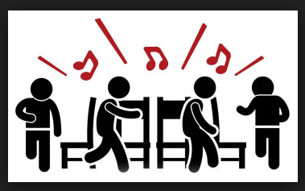

Introduction: The game of Musical Chairs has traditionally been used to teach the concept of scarcity. This activity expands on this idea by defining a chair as a home, and contemplating what’s it like when this home no longer available.

Time Required: 30-40 minutes.

Materials:
- Device for playing music
- Chairs arranged in a circle
- Visual- Situation Card Example
- Activity Cards- Situation Cards (one for each student)
- Writing tools

Objectives:
- The student will be take on the identity of a fictional homeless character.
- The student will participate in the scarcity activity of musical chairs.

Procedure:
- Collect the needed materials and set up the chairs.
- Display Situation Card Example and review its contents with the students.
- Instruct students to write a situation card based on a fictional character. Possible characters include: Oliver Twist, Peter Pan, Maniac Magee, Mowgli, Tarzan, Jane Eyre, Sophie (The BFG), and Violet, Klaus & Sunny Baudelaire.
- Introduce the activity by telling the students they will be playing an interactive game based on the game musical chairs. Explain that every chair represents a home.
- Play the game.
- When the music stops, the person without a “house” must read their situation card to the group and go to the back of the room.
- Play as time allows.
- Debrief the activity by discussing the situations of the various characters and how not having a home influenced their life and the choices they made.

Situation Card Example

Name: Hansel Woodson

Age: 8 years

Living Situation:
Currently living in the forest with my sister Gretel after being abandoned by our father and step-mother. We are looking for food and shelter. Hopefully a kind stranger will help us.

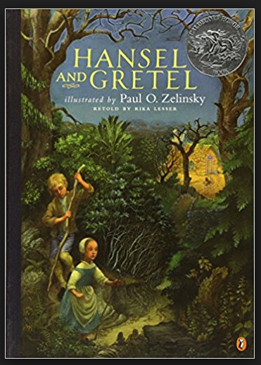

Situation Cards

Name:  Age:  Living Situation: | Name:  Age:  Living Situation:
Name:  Age:  Living Situation: | Name:  Age:  Living Situation:
Name:  Age:  Living Situation: | Name:  Age:  Living Situation:

