*Ella Earns Her Own Money*

Written by Katie Smith Lisa- Illustrated by Mike Moran

[Lerner Publishing, 2014]

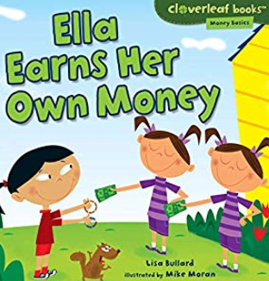

**Resource Relay Race**

**Introduction**: This lesson reviews productive resources as they relate to some of the characters and situations in *Ella Earns Her Own Money* by Lisa Bullard. What could be better than a competitive race around the room while solving puzzles and reviewing economic concepts?

**Concepts**:

* **Natural Resources** – gifts from nature, such as land, water and trees
* **Human Resources**- human effort directed toward producing goods and services (labor)
* **Capital Resources** – goods produced and used to make other goods and service (tools)

**Objectives**:

* The student will review the terms natural resources, human resources, and capital resources
* The student will participate in a class problem solving activity

**Materials:**

* Three sets of puzzle cards copied on card stock (for ease of organization use a different color for each set)
* Visual –Author Puzzle
* Writing tools
* Ziploc Bags
* Optional- A copy of “Make Your Own Puzzle” for each student

**Procedure**:

1. Prepare material prior to class.
2. Introduce the lesson by telling the students that after a brief review they will be participating in a competitive class activity.
3. Read the book *Ella Earns Her Own Money* to the class, if time allows. Make a point of the various jobs Ella performs for her family and friends. Explain that if Ella had not helped these people with these tasks, they would have had to do the work by themselves.
4. Review the concepts of natural resources, human resources, and capital resources. **Natural Resources** are gifts from nature, such as land, water and trees. **Human Resources** are human effort directed toward producing goods and services. **Capital Resources** are good produced and used to make other goods and service.
5. Explain to the students that they will be putting this knowledge to work by assembling three puzzles.
6. Display the Author puzzle sheet and review its contents. This works well if you have two versions of the puzzle; one as a whole sheet and the other cut up in the three puzzle pieces.
7. Tell the students that there are three puzzles in each bag. Explain that each team is to assemble these puzzles on the predetermined flat surface.
8. Divide the class into three teams. (Two teams will work for smaller classes.)
9. Give each team a Ziploc bag with a complete puzzle set.
10. Instruct the teams that one student from each team is to take the bag to the flat surface, remove a piece and try to place it correctly. (This should become easier as the relay progresses.) That student then returns, giving the bag to the next person in line, who then repeats the same procedure until all three puzzles are completed.
11. The winning team gets bragging rights.
12. Review the content on the puzzle pieces, discussing the importance of the productive resources involved.

**Extension Activity**: Students may create their own puzzle using the “Create Your Own Puzzle” activity sheet.

Visual

Writing a Book

* *

Laptop Computer Apple

(for a snack)

**

Author- Lisa Bullard

#1 Cleaning the Garage

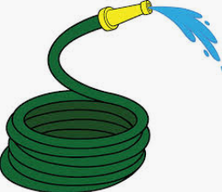 

Water Mop & Bucket

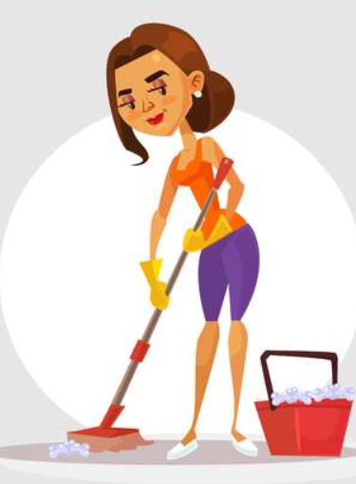

Ella’s Grandma

# 2 Pet Care

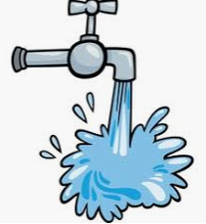 

Water Dog Bathtub

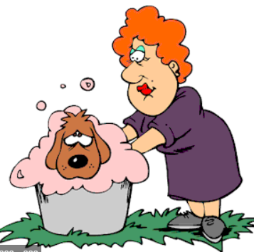

Ms. Lowry

#3: Lawn Care

 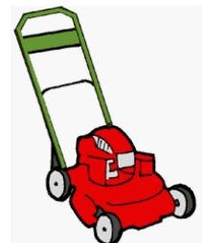

Grass Lawn Mower

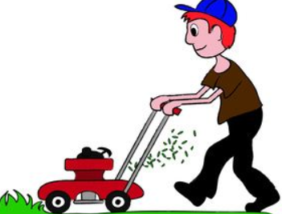

Mr. Hanson

Create Your OwnPuzzle

Some character suggestions:

Human Resources: Ella (cleaning the car with water from a hose), Ella (feeding her pet fish who lives in a bowl) Aiden’s mom, (planting flowers in her garden using a shovel),

Natural Resource Capital Resource

Human Resource