**Bunnyland:**

**Economic and Personal Finance Lessons for the Primary Classroom**

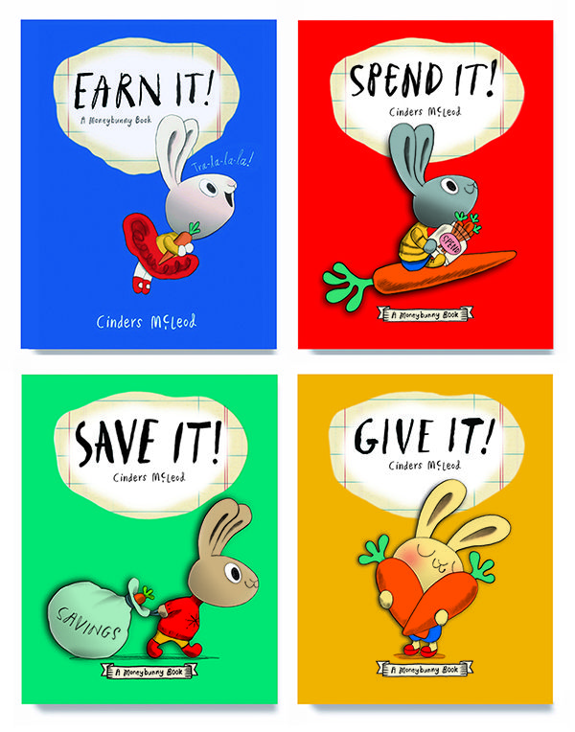

**Table of Contents**

**Introduction** Page 3

Lesson 1 *Earn It!* [Investing in Human Capital] Pages 4-9

Lesson 2 *Save It!* [Saving Goals] Pages 10-17

Lesson 3 *Spend It!* [Opportunity Cost] Pages 18-26

Lesson 4 *Give It!* [Goods & Services] Pages 27-34

**Bibliography**

*New Picture Books featuring Economic Concepts*  Page 35

**Bunnyland: Economic and Personal Finance Lessons for the Primary Classroom**

**Introduction**

*Bunnyland: Economic and Personal Finance Lessons for the Primary Classroom*is a set of lessons and activities based on the *Moneybunny Series* written and illustrated by Cinders McLeod. The four titles describe the books’ featured concepts of earning, spending, saving, and giving, with the common theme of guided decision-making appearing in every book. This curriculum reinforces the understanding that young students can benefit from learning about economics, personal finance, and decision-making skills. By introducing these concepts early, students can build on them as they go through school and enter adult life.

Each lesson includes reading information, a story synopsis, discussion questions, a structured lesson plan, an assessment, cross-curricular enrichment activities, and a YouTube book reading link. An annotated bibliography, featuring picture books containing strong economic content is also provided. It is to be noted that these lessons and activities do not need to be taught in any specific order. Each book stands alone and can be utilized when introducing a specific concept.

These lessons were developed with consideration of the limited time available to classroom teachers, librarians, and resource specialists. The interdisciplinary approach to instruction has become a necessity as educators not only work to cover demanding curriculum coverage, but also reinforce student learning by encouraging them to make content connections.

The materials and preparation time required for these lessons and activities are intentionally minimal. In most cases the featured book, a document camera, the ability to mass-produce activity sheets, paper, crayons, and writing tools are all that is required. The lessons are designed to take between 15-30 minutes and can be taught in designated social studies or language arts instructional classes or as a stand-alone enrichment activity.

The standards referenced in this unit are Virginia’s Standards of Learning. They may be found on the Virginia Department of Education’s website:

<https://www.doe.virginia.gov/testing/index.shtml>

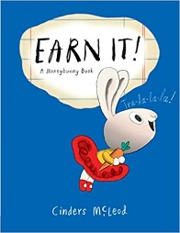

***EARN IT!***

[Penguin, 2017]

ISBN  978-0-399-54444-6

Reading Level 2.0, Interest Level P-2

**Story Synopsis:** Bun loves to sing and aspires to use her talent to be rich and famous. Bun’s mother explains to her that there is a lot of work involved in becoming a singing star. After considering her mom’s advice about working hard to earn money, Bun realizes that feeling good about the effort she would need to achieve her dream has merit of its own.

**Discussion Questions**:

Show the cover of the book to the students. Tell them this is a story about a rabbit named Bun who wants to be rich and famous. Instruct the students to listen carefully as they will be asked questions after the book is read. Read the book and ask the following questions.

1. Bun wants to be rich and famous. How does she plan to do this?

[Bun loves to sing and wants to be a star preforming on stage.]

1. What is used as money in Bunnyland?

[Carrots are used as money in Bunnyland.]

1. Work is any activity we do for which someone will pay us. What were some of the things Bun does to earn carrots? [Each week she walks the dog for one carrot, sings her brother to sleep for one carrot, then she decides to help her mother in the garden for one carrot.]
2. If Bun earns three carrots a week, how many carrots would she earn in a month? [She would earn twelve carrots a month.]
3. Why do you think Bun’s mother wants her to know it’s important to work very hard to possibly become rich and famous? [Possible answers: Bun’s mother knows that it’s not easy to become a singing star. Bun’s mother may not what her to be disappointed. Bun’s mother knows that it is important to get a good education and learn how to be the best you can be.]
4. Do you think Bun will become a rich and famous star when she grows up? [Possible answers: She might if she works hard and is lucky. She will always be a good singer, but she is unlikely to be rich and famous. Maybe she will become a music teacher, record producer, songwriter, music engineer, booking agent, or concert promoter.]
5. Human capital is a set of skills we have that we can improve on by getting education and training. By helping her mother and earning carrots, Bun is learning to do many things. She is investing in her human capital. What other jobs could she do by using the skills she is learning? [Possible answers: Bun could work with animals and be a veterinarian or dog groomer. She could work with children and be a childcare provider or teacher. She could work with plants and be a gardener or florist.]

**Lesson 1**

**Investing in Human Capital**

**INTRODUCTION**: Bun wants to be a singing star. Bun’s mother advises her to take singing lessons if she wants to be rich and famous. She is encouraging her daughter to invest in her human capital which is defined as labor resources that can be improved though investments in education, training, and health care.

**TIME ALLOCATION:** 20-25 minutes

**MATERIALS:**

* Book- *Earn It!* by Cinders McLeod
* Activity Sheet-What Human Capital Do You Have?
* Assessment
* Writing tools
* Optional: Document camera

**OBJECTIVES:**

* The student will listen to a story and determine the human capital of the main character.
* The student will define and understand the meaning of human capital.
* The student will make decisions and choices concerning an evaluation of personal skills and abilities.

**ECONOMIC CONCEPTS:**

* **Choice** – selecting something over another thing.
* **Human Resources** – the quality and quantity of human effort directed toward producing goods and services.
* **Human Capital** – labor resources that can be improved though investments in education, training, and health care.
* **Money** - Anything that serves as a medium of exchange, a standard of value, and a store of value.
* **Scarcity** – the condition of limited resources-- because resources are limited, people must make choices.

**VIRGINA STANDARD OF LEARNING- HISTORY AND SOCIAL SCIENCE**

K.8 The student will match simple descriptions of work that people do with the names of those jobs.

K.9 The student will

a) recognize that people make choices because they cannot have everything they want; and

b) explain that people work to earn money to buy the things they want.

1.9 The student will recognize that people save money for the future to purchase goods and services.

2.10 The student will explain that scarcity (limited resources) requires people to make choices about producing and consuming goods and services.

**PROCEDURE**:

1. Introduce the lesson by telling the students that they will be listening to a story about a talented bunny who wants to be rich and famous.
2. Read *Earn It!* to the students. This takes four to five minutes.
3. Upon completion of the story ask the students what skills Bun needed to perform her different jobs. While she wanted to be a famous singer, she was also earning money taking care of her little brother, walking the family dog and helping her mother in the garden.
4. Discuss the fact that Bun’s mother suggested she take singing lessons. She had to learn to do things; invest in her own human capital. Define **human capital** as: the health, education, experience, training, skills, and values of people.
5. Ask the students if they have a goal of their own; if they want to do something special. Suggest to them that they are already learning skills to achieve a future goal.
6. Inform the students that they will be doing an activity that will demonstrate that they have already invested in their own human capital.
7. Distribute the activity sheets and writing tools. Read the directions to the students. Say “Look at each picture and decide if you have that skill. Put a check in each correct box. Put a circle around the skills you don’t have now, but would like to. Put a square around three skills you would like to get better at doing.”
8. Allow the students to interpret the illustrations anyway they wish. For example, the first picture could illustrate shoe-tying or curling one’s tongue. The purpose of this activity is to demonstrate that the students have accumulated many more skills and abilities than they are aware of. Note: by allowing the students to choose only three skills that they can improve on, they have to make thoughtful choices.
9. Conclude the activity by discussing the students’ views on their own human capital.

**ASSESSMENT:** This assessment may be used as an activity sheet done by individual students, small groups or displayed on a document camera and conducted as a teacher-directed class activity.

Check for understanding.

Answers 1. Nurse, 2. Vet (Veterinarian) 3. Clerk, 4. Dentist, 5. Barber, 6. Astronaut

**ENRICHMENT & EXTENSION**:

* Art – Create a class collage using photos, drawings, words, and clippings from old magazines that depicts different kinds of jobs.
* Creative Problem Solving- Challenge the students to create a class ABC Book that contains a job for every letter in the alphabet.
* Online Resources: *Exploring Human Capital with Primary Children: What We Learn in School* Does *Matter.* Bonnie T. Meszaros and Mary C. Suiter. Social Studies and the Young Learner 27 pp. 30–32 ©2014 National Council for the Social Studies.

<https://www.socialstudies.org/system/files/publications/articles/yl_27011430.pdf>

**YouTube Book Reading Link:** <https://www.youtube.com/watch?v=3ceVZG2SsGs> (4:34 Reading Time)

Activity Sheet-

What Skills do You Have?

Directions: Look at each picture and decide if you have that skill. Put a check in each correct box. Put a circle around the skills you don’t have now, but would like to. Put a square around three skills you would like to get better at doing.

|  |  |  |  |
| --- | --- | --- | --- |
| 🞎YES 🞎NO | 🞎YES 🞎NO | 🞎YES 🞎NO | 🞎YES 🞎NO |
| 🞎YES 🞎NO | 🞎YES 🞎NO | 🞎YES 🞎NO | 🞎YES 🞎NO |
| 🞎YES 🞎NO | 🞎YES 🞎NO | 🞎YES 🞎NO | 🞎YES 🞎NO |
| 🞎YES 🞎NO | 🞎YES 🞎NO | 🞎YES 🞎NO | 🞎YES 🞎NO |

**Extra Credit**: On the back of this paper draw some other skills that you have.

Assessment

**Job Poems**

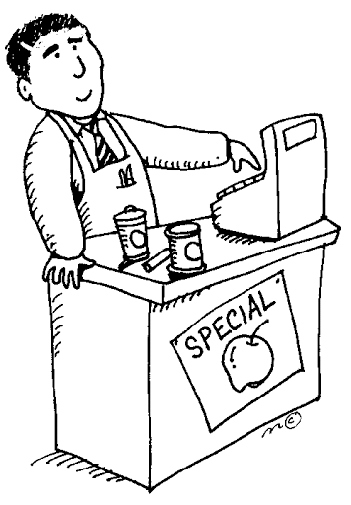

Directions: A job is the work that a person does regularly in order to earn money. Use the jobs listed in the word box to complete the rhymes.

1. When people are sick and don’t want to get worse

I help them get healthy. I am a _________________.

1. I love animals and take care of your pet.

Cats, dogs, and rabbits are all loved by the ______________.

1. Behind the cash register is where I do my work.

I’m an essential worker. I’m a store ______________.

1. Take care of your teeth, I must insist.

I rather not fill cavities even though I’m a ___________.

1. Cutting hair is my specialty, yes sir.

I help people look good. I’m a ____________.

1. Outer space is my special work spot.

I travel in rockets. I’m an ____________.

Word Box

Astronaut Barber Clerk

Nurse Vet Dentist

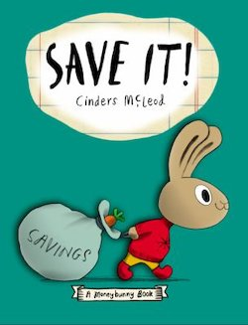

***SAVE IT!***

[Penguin, 2019]

ISBN  978-1-9848124-0-7

Reading Level 1.0, Interest Level P-2

**Story Synopsis:** Honey works hard taking care of her five younger siblings for which she earns two carrots a week. She would really like to have a quiet place of her own. Her father suggests she save her money to buy her own playhouse. After some creative problem solving, Honey decides to save a portion of her weekly allowance. This method might take a while longer, but she will still be able to enjoy some of her favorite treats.

**Discussion Questions**:

Show the cover of the book to the students. Tell them this is a story about a rabbit named Honey who wants to save money to buy a playhouse. Instruct the students to listen carefully as they will be asked questions after the book is read. Read the book and ask the following questions.

1. Money is anything that serves as a medium of exchange. What do rabbits use for money in Bunnyland? [Carrots are used for money.]
2. Work is any activity we do for which someone will pay us. What sort of work does Honey do to earn carrots? [She looks after her siblings.]
3. How many carrots does Honey earn each week for taking care of her brothers and sisters? [She earns 2 carrots a week.]
4. Honey would like her own house so she could get some peace and quiet. Her dad tells her that this would be too expensive. What do they decide would be a less expensive getaway for Honey to purchase? [He suggests a playhouse.] How much would a playhouse cost? [A playhouse cost 10 carrots.]
5. How many weeks would Honey need to save 10 carrots? [She would need to work to save all her carrots for 5 weeks.]
6. Honey would like to spend her money on fun things as well as save it. Her dad tells her that it is her money and she can decide what to do with it. What does Honey decide to do? [Honey decides to spend one carrot each week and save one carrot each week.]
7. Now that Honey has decided to save just one carrot each week, how long will it take her to save enough to buy a playhouse? [It will take Honey 10 weeks to save enough money to purchase a playhouse.]
8. Is the delivery person who brought the playhouse to Honey performing a service? [Yes, delivering goods is an action.] Is the playhouse itself a good or a service. [The playhouse is a good; it is a tangible thing.]
9. Was Honey able to stick to her plan and purchase a playhouse in 10 weeks? [Yes, she was.] Do you think she made the right choice? [Answers will vary.]

**Lesson Plan 2**

**Saving Goals**

**Introduction**: Honey’s problem-solving skills, commitment, and self-discipline teaches students that saving money for a specific goal can be a rewarding experience.

**Time:** 20-25 minutes

**Materials**:

* Picture book *Save It!* by Cinders McLeod
* Visual1: Economic and Personal Finance Terms
* Visual 2: Honey’s Incentives to Save
* Activity Sheet: *Save It!*
* Assessment Sheet
* Writing tools
* Optional: Document camera

**Objectives:**

Students will:

* Be introduced to the concepts of: money, saving, spending, choices, goods, services
* Learn about setting a savings goal
* Complete an activity sheet

**Virginia Standards of Learning – History and Social Science**

K.9 The student will   
a) recognize that people make choices because they cannot have everything they want; and  
b) explain that people work to earn money to buy the things they want.

1.9 The student will recognize that people save money for the future to purchase goods and services.

2.11 The student will explain the responsibilities of a good citizen, with emphasis on

d) demonstrating self-discipline and self-reliance

**Procedure:**

1. Prepare and collect materials prior to class. The visual, Economic and Personal Finance Terms, may be posted in the front of the room or displayed using a document camera and reviewed with the students.
2. Introduce the lesson telling the students that the story in today’s lesson is based on a story about a hard-working bunny named Honey who wants to save money for something special.
3. Read the book *Save It!* to the students. This takes about 3 minutes.
4. Ask the students what they would do if they earned two dollars helping a neighbor pull weeds in the garden. [Answers will vary.]
5. Explain to the students that the payment people earn from work is called **income**.
6. Remind the students that **money** is an agreed upon medium of exchange and that in Bunnyland, carrots are money.
7. Tell the students that when someone saves their money to buy a specific good or service in the future it is called a **savings goal**.
8. Ask the students the following book-related questions:

* What kind of work did Honey do to earn income? [She took care of her brothers and sisters. This is an example of a service.]
* Why did Honey decide to save her money? [She wanted to buy a playhouse.]
* What was Honey’s savings goal? [Honey’s savings goal was ten carrots.]
* How many weeks did it take Honey to save ten carrots? [It took her ten weeks.]
* Why did she decide not to save both of the carrots she earned each week? [Honey made a **choice**. She wanted some money to spend on treats so it took her longer to get to her savings goal.]
* How did Honey feel at the end of the story? [She was happy to have a playhouse where she could find a quiet place to be by herself.]

1. Display the Visual 2, Honey’s Incentives to Save.Tell the students that the word **incentive** means the same thing as reason.
2. Review the visual with the students, pointing out that these are things Honey may want in the future. Ask if they can think of other things to add to these illustrations.
3. Say “Distribute the activity sheet and writing tools. Read the directions to the students. Honey wanted to save money to buy a playhouse so that she could have some time to herself. Can you think of other reasons to save money? In each box draw a picture of something that you would like to save money for. Be prepared to share your work with the class.”
4. Encourage them to be creative and think the goods or services they would like to save for that would help them and their families. Students may work individually or in small groups.
5. Ask students, when they have filled in all four squares, to circle the one item that they think is the most important. Explain that this is their choice. Their second choice would be their opportunity cost.
6. Clarify the concept of opportunity cost by explaining that because we cannot have everything we want (scarcity), we must make choices. Each time we make a choice, we give something up. There is always a next best alternative when making any choice. The value of this next best alternative (or second favorite choice) is the opportunity cost.
7. Encourage class discussion concerning items illustrated on the activity sheets.

**ASSESSMENT:**

1. Distribute the assessment sheet and writing tools. This may be completed by individual students, small groups, or, using a document camera, or as a teacher-directed class activity.
2. Read the directions to the students.
3. Check for understanding. Answers: 1. Honey was saving for a playhouse. 2. Honey will spend 10 carrots on the playhouse. 3. It will take Honey 10 weeks to reach her savings goal.

**ENRICHMENT AND EXTENSION**:

* **Rhyming** – Tell the students that in this story Honey, bunny, and money are rhyming words. They sound alike. Challenge them to think of other words in the story and find words that rhyme with them. Possible words include: Dad, Earn, Playhouse, Save and Spend.
* **Creative Problem Solving** – Carrots are money in Bunnyland. We save our money in banks and credit unions where it is safe. Do you think there are banks in Bunnyland? If so, what would they look like? Would there be wallets and pocketbooks in Bunnyland?

What do you think they would look like?

**YouTube Book Reading Links:**

<https://www.youtube.com/watch?v=-x97ApD-Cd0> (3:19 Reading Time)

<https://www.youtube.com/watch?v=1BDayN0lEEY> (7:45 Reading Time)

Visual 1

***Save It!***

**Economic and Personal Finance Concepts**

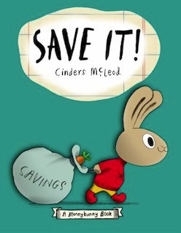

**Choice**- You cannot have all the goods and services you want, so you must choose some things and give up others.

**Income**- Payments earned.

**Goods**- Things that can be bought and sold such as toys, books, and playhouses.

**Money**- Anything that serves as a medium of exchange. Example: Carrots are money in Bunnyland.

**Savings**- Money set aside now for a future use.

**Opportunity Cost** - The next best choice that is given up when you make a decision is your **opportunity cost.**

**Savings Goal**–A plan to save money to buy a specific good or service in the future.

**Services**– Activities performed by people such as childcare, and delivering items.

**Spending**– To use money now to buy goods and services.

Visual 2

**Honey’s Incentives to Save**

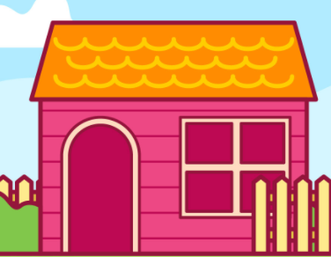

Honey saved 10 carrots to buy a playhouse. She has some other ideas of things she would like to buy. If you were Honey, what would be the first item you would save carrots for? Why?

|  |  |
| --- | --- |
| **6 carrots -** for one month of lessons  Craft clipart 1 » Clipart Station  Take art lessons at the community center. | **5 carrots -** buying it used from a friend  **Buy used from school friend for 8 carrots.**  tv game clipart - Clip Art Library  Buy a gaming system for her playhouse |
| **4 carrots** – nice garden gloves and a new tie    fathers day gift clipart - Clip Art Library  Buy a nice Father’s Day gift for her dad | **3 carrots** – ticket for group bus trip  Sand Bucket Clipart Black And White Clipart Panda Free Clipart | Beach  clipart, Free clip art, Clip art  Go on a day trip to the beach |

Activity Sheet

Saving Money

Honey wanted to save money to buy a playhouse so that she could have some time to herself. Can you think of other reasons to save money?

Directions: In each box draw a picture of something that you would like to save money for. Be prepared to share your work with the class.



|  |  |
| --- | --- |
|  |  |
|  |  |

Assessment Sheet

*Save It!*

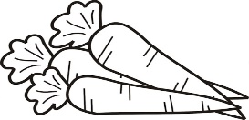

Honey earns income for providing a service for her family. She takes care of her five brothers and sisters for two carrots a week. Carrots are money in Bunnyland. Honey wants to buy a playhouse for ten carrots so that she can have a place of her own. Help her reach her savings goal.

1. What good is Honey saving for?

_____________________________________________________

_____________________________________________________

1. How much will Honey spend on this good?

________________________________________________________________________________________________________________

1. If Honey saves one carrot each week, how long will it be before she reaches her savings goal? ________________________________________________________________________________________________________________

Extra Credit:

Draw a picture of Honey’s playhouse.

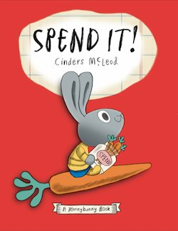

***SPEND IT!***

[Penguin, 2019]

ISBN  978-0-399-54446-0

Reading Level 1.0, Interest Level P-2

**Story Synopsis**: In Bunnyland, Sonny gets three whole carrots for his weekly allowance. He wants to buy everything with it! But he soon discovers his money won't go that far. His mother tells him he needs to make some choices. Even though this doesn't sound like much fun, Sonny soon learns what’s really important and how to make an informed decision.

**Discussion Questions**:

Show the cover of the book to the students. Tell them that this is a story about a rabbit named Sonny who will be making a decision on how to spend his money. Instruct the students to listen carefully as they will be asked questions after the book is read. Read the book and ask the following questions.

1. What do the rabbits use for money in Bunnyland? [Carrots are used for money.]
2. How many carrots does Sonny get for his allowance? [Every Saturday Sonny gets three carrots for his allowance.]
3. Sonny wants to buy everything he sees. What three things does Sonny want to buy? [He wants to buy a toy rocket, a pogo stick and a bouncy castle.]
4. What is Sonny problem? [He only has three carrots and can’t buy everything.]
5. Sonny’s mom says he will have to make a choice. What is a choice? [A choice is making a decision or selection when faced with two or more alternatives or options.]
6. How much does each item cost? [The toy rocket costs two carrots, the pogo stick costs three carrots, and the bouncy castle costs 100 carrots.]
7. Why does Sonny decide not to buy the bouncy castle? [He does not have 100 carrots. Plus, he says it is ridiculous that it cost that much money.]
8. Why does Sonny decide not to buy the toy rocket? [He already has lots of toys.]
9. Sonny decides to buy the pogo stick. Do you think he made the right decision? [Answers will vary. Some students may say he should have not spent all his money. Others will say he choose the right item because that is how much money he had to spend or what he wanted the most.]
10. Opportunity cost is the next-best thing we give up to choose the thing we want. When Sonny decided to purchase the pogo stick, he gave up the next choice he would have made. What was Sonny’s opportunity cost? [If Sonny had not selected the pogo stick, he would have bought the toy rocket. The toy rocket was his opportunity cost.]
11. If Sonny really, really, really wanted to buy the bouncy castle, what could he have done? [Sonny could have saved his allowance and worked to earn extra money until he had the 100 carrots to buy the bouncy castle.]

**Lesson 3**

**Opportunity Cost**

**INTRODUCTION:** In this activity,students learn the hard lesson of making a choice. Just like Sonny, they will have to make a decision, thus giving up other possible choices.

**TIME REQUIRED**: 25-30 minutes.

**OBJECTIVE:**

* The student will be introduced to the concept of opportunity cost: “In a choice, the benefit expected form the highest valued alternative forgone; or what you give up when you make a choice.”

**MATERIALS**:

* Book *Spend It!* by Cinders McLeod
* Prepared color sheets (duplicated front-to-back)
* Crayons or colored pencils
* Scissors
* Optional: Document Camera

**ECONOMIC CONCEPTS:**

* **Choice** - You cannot have all the goods and services you want, so you must choose some things and give up others. A choice is the decision you make among alternatives or possibilities.
* **Money** - Anything that serves as a medium of exchange, a standard of value, and a store of value.
* **Opportunity Cost** - The next best choice that is given up when you make a decision is your opportunity cost.
* **Spend** - To use money now to buy goods and services.
* **Want**- A desire that can be satisfied by consuming or using a good or service.

**VIRGINA STANDARD OF LEARNING- HISTORY AND SOCIAL SCIENCE**

K.9 The student will

a) recognize that people make choices because they cannot have everything they want; and

b) explain that people work to earn money to buy the things they want.

1.8 The student will explain that people make choices because they cannot have everything they want.

2.10 The student will explain that scarcity (limited resources) requires people to make choices about producing and consuming goods and services

3.10 The student will identify examples of making an economic choice and will explainthe idea of opportunity cost (what is given up when making a choice).

**PROCEDURE:**

1. Prepare the materials prior to class. Run off the toy color sheets, front to back in different combinations. For example: carrot/pogo stick, bouncy castle/carrot, toy rocket/pogo stick and so forth.
2. Introduce the lesson by reading the book *Spend It!* by Cinder McLeod to the students. This will take between 4-5 minutes.
3. Ask the students why Sonny had to make a choice between a pogo stick, toy rocket, and bouncy castle. [He had a limited amount of money.]
4. Inform the students that they will be helping create a bulletin board display. This display will show colored pictures of the three choices Sonny had. It will also include carrots, which are used as money in Bunnyland.
5. Distribute the prepared activity sheets and coloring tools.
6. Instruct the students to color both sides to the best of their ability. When the students are finished, give them a pair of scissors and inform them they must cut out ONE of their colored toys for the display. Explain that the other side will be destroyed, so the chance to display that side will be their opportunity cost. (Be prepared for complaints from the students, some who will have a hard time choosing which side to keep.)
7. Display student work on a bulletin board titled “Spend It! Opportunity Cost.”

**ASSESSMENT:**

The assessment may be used as an activity sheet done by individual students, small groups or displayed on a document camera and conducted as a teacher-directed class activity.

If the entire class is participating, allow the students to vote for their choice. Emphasize that the activity not selected is their opportunity cost; the next best choice that is given up when a decision is made.

**ENRICHMENT & EXTENSION:**

* **Creative Writing** – Story Starter. Explain to the students that they will be writing or illustrating a story titled “A Story of Opportunity Cost.” Their story can be about a choice they made while watching television, playing games, going shopping, or picking out what to wear to school. The story should include their choice, and what they gave up, their opportunity cost.
* **Online Resources**- From the publisher, a set of eleven activity sheets. <https://storage.googleapis.com/classroom-portal-production/uploads/2021/04/9c78f1c0-monneybunny-activities.pdf>

**YouTube Book Reading Link**: <https://www.youtube.com/watch?v=ZCZ912r1OM8> (4:22 Reading Time)

Color Sheet #1

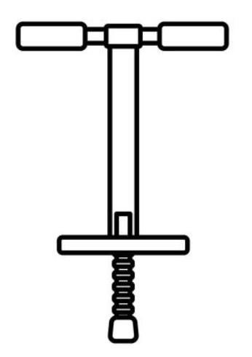

Pogo Stick

Color Sheet #2

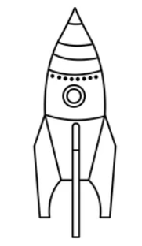

Toy Rocket

Color Sheet #3



Bouncy Castle

Color Sheet #4

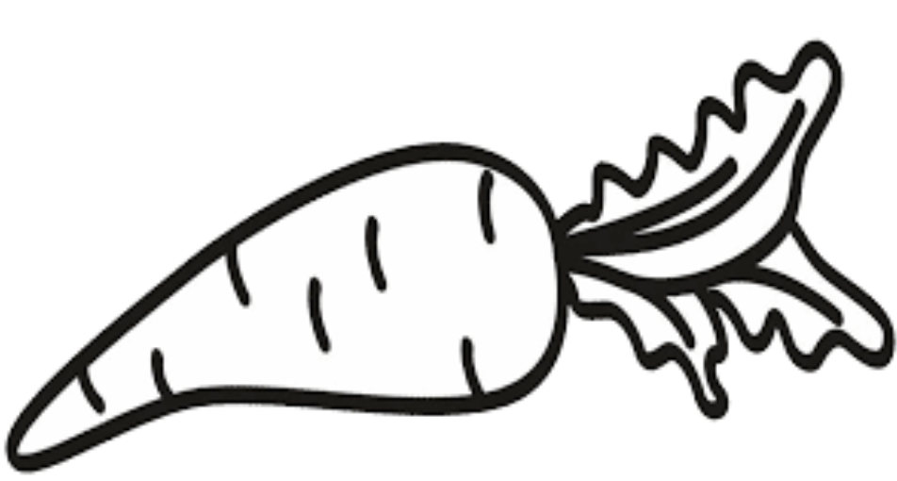

Carrot

Assessment Sheet

Opportunity Cost

It’s raining outside and your teacher tells the class that they have two choices of how the use your recess time. You can go to the library to check out books, or go to the computer lab to play educational games. You can’t do both!

Circle your choice:





1. Which activity did you choose? _____________________________________
2. What is your opportunity cost of your choice? _____________________________________

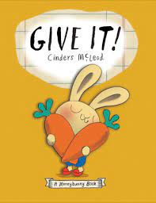

***GIVE IT!***

[Penguin, 2020]

ISBN  978-1-9848124-3-8

Reading Level 2.0, Interest Level P-2

**Story Synopsis**: When Chummy’s grandmother gives him ten carrots for his birthday, he has to make some decisions. He definitely wants to help others, but he is not sure of the best way to do so. With some sensible discussion, informative graph making, and charitable consideration, he makes a choice that will have an impact on others and the environment.

**Discussion Questions**:

Show the cover of the book to the students. Tell them this is a story about a rabbit named Chummy who gets a nice birthday gift from his grandmother. He wants to help others and needs to make a decision concerning his best choice. Instruct the students to listen carefully as they will be asked questions after the book is read. Read the book and ask the following questions.

1. What do the rabbits use for money in Bunnyland? [Carrots are used for money.]
2. How many carrots did Chummy’s grandmother give him for his birthday? [Chummy’s grandmother gave him ten carrots.]
3. What did Chummy’s grandmother suggest he do with his money? [She suggested he spend some of it on himself and some of it helping others.]
4. At first what did Chummy want to spend his money on? [He wanted to buy a superhero costume so he could save the world. He wanted to fight dragons.]
5. Chummy’s grandmother says he will have to make a choice between saving the world or saving Bunnyland. What is a choice? [A choice is making a decision or selection when faced with two or more alternatives or options.]
6. Instead of fighting dragons, Chummy decided to do what? [Chummy decided to help bees.]
7. Chummy’s grandmother also reminded him that if he spent all his money on a superhero costume, he would he have no carrots left to help others. What was he suggestion to this problem? [She suggested he could just buy part of the costume; the cape.]
8. Chummy comes up with two plans to help others. What are they? [In Plan 1 he spends all the money on a superhero costume. In Plan 2 he spends five carrots on a cape and five carrots for flowers for the bees.]
9. After lunch with his grandmother, Chummy comes up with another plan. What is his Plan 3? [He decides to spend all his carrots on flowers for the bees.] Do you think this was a good decision? [Answers will vary.]
10. Opportunity cost is the next-best thing we give up to choose the thing we want. When Chummy decides to spend all his carrots on flowers for the bees, he gave up the next choice he would have made. What do you think Chummy would have selected Plan A or Plan B? [If Sonny had not decided to spend all his carrots on flowers for the bees, he likely would have selected Plan B. That way he would have gotten something for himself, and something for the bees. Plan B was his opportunity cost.]
11. At the end of the story, Chummy and his grandmother planted snapdragon flowers in the garden to attract the bees. Do you think this choice of flower is funny? Why? [At the beginning Chummy wanted to fight dragons, at the end he was using snapdragon flowers to help the bees and thus the environment.]

**LESSON 4**

**Philanthropy: Goods & Services**

**INTRODUCTION:** Chummy loves his Gran, superheroes, and helping others. In this lesson students will discover that the decision to help others is as empowering as wearing a cape and fighting dragons.

**TIME REQUIRED**: 25-30 minutes.

**OBJECTIVES:**

* The student will recognize that people make choices because they can not have everything they want.
* The student will participate in a decision-making process

**MATERIALS**:

* Book *Give!* by Cinders McLeod
* Visual 1 – Lend a Helping Hand to Phil’s Aunt Trophy
* Activity Sheet/Visual – Lend a Helping Hand
* Paper and writing tools
* Document camera or another display devise.

**ECONOMIC CONCEPTS:**

* **Choice** - You cannot have all the goods and services you want, so you must choose some things and give up others. A choice is the decision you make among alternatives or possibilities.
* **Goods**- Things that can be bought and sold such superhero costumes and flowers.
* **Money** - Anything that serves as a medium of exchange, a standard of value, and a store of value.
* **Opportunity Cost** - The next best choice that is given up when you make a decision is your opportunity cost.
* **Philanthropy** - desire and active effort to help other people
* **Services**– Activities performed by people such as planting a garden and picking cherries.
* **Spend** - To use money now to buy goods and services.
* **Want**- A desire that can be satisfied by consuming or using a good or service.

**VIRGINA STANDARD OF LEARNING- HISTORY AND SOCIAL SCIENCE**

K.9 The student will

a) recognize that people make choices because they cannot have everything they want

1.7 The student will explain the difference between goods and services and describe how people are consumers and producers of goods and services.

1.8 The student will explain that people make choices because they cannot have everything they want.

1.10 The student will apply the traits of a good citizen by

a) focusing on fair play, exhibitinggood sportsmanship, helping others, and treating others with respect

2.10 The student will explain that scarcity (limited resources) requires people to make choices about producing and consuming goods and services

3.10 The student will identify examples of making an economic choice and will explainthe idea of opportunity cost (what is given up when making a choice).

**PROCEDURE:**

1. Prepare the materials prior to class.
2. Introduce the lesson by showing the cover of *Give It!* by Cinder McLeod to the students.

Explain that the main character in this book loves his grandmother, superheroes, and helping others. Read the book. This will take between 4-5 minutes.

1. Ask the students the following questions:

* Why did Chummy decide to spend all his carrots on buying flowers for the bees? [Flowers are food for the bees.]
* How did Chummy help the bees? [He planted the flowers in the garden.]
* Do you think helping plants and animals is a good thing to do? [Possible answers: We should take care of the environment. Animals and plants help us. Bees make honey.]

1. Ask students to consider that charity can come in many different forms and isn’t always about giving money or objects (goods). Sometimes helping others by giving of your time, (performing a service) can also be meaningful. Remind them that we don’t help others because we expect something in return.
2. Display Visual 1, Phil’s Aunt Trophy. Explain to the students that Chummy’s friend Phil has an Aunt Trophy who is older and has not been well. Chummy, his grandmother, and some other friends try to think of ways to help Aunt Trophy. They come up with five goods or services that will help her. Their ideas are written on a hand print and are an assortment of goods and services.
3. Define **goods** as Things that can be bought and sold, tangible items, and **services** as activities performed by people.
4. Review the things Phil’s friends would like to do to help his aunt and discuss if these are goods or services.

1. Walk the dog: service

2. Cook her dinner: cooking is a service; the food is a good

3. Pay her power bill: helping someone with their finances is a service

4. Buy her groceries: shopping is a service; the items purchased are goods

5. Weed her garden: helping in the garden is a service

1. Explain that helping other is called **philanthropy**. Philanthropy is a personal interest in helping others.
2. Distribute or display Visual 2. This is a quick brainstorming activity to help students think of ways they can help others. Challenge students to come up with at least two ideas for each category. This works well as a teacher-directed activity, by displaying the visual and writing in ideas suggested by the students.
3. Distribute paper and pencils to each student. Instruct them to trace their hand and using ideas from the brainstorming activity or some of their own, write or illustrate a way could help others on each finger.
4. Encourage them to share their best idea with the class. Ask the students if the suggested idea is a good or a service.

**ASSESSMENT**

* Distribute *Bunnyland Goods and Services* and writing tools.
* Read the directions to the students.
* Check for understanding. Superhero Costume: GOOD, Planting Flowers: SERVICE, Picking Fruit: SERVICE, Garden Tool: GOOD, Collecting Honeycombs: SERVICE, Honey: GOOD.

**ENRICHMENT & EXTENSION**

* **Art** – Chummy wanted to be a superhero and save the world. Create a superhero who specializes in helping others. Give him/her a special name like Captain Charity or Great Giver. Draw a picture of this new superhero.
* **Class Charitable Activity** – Encourage students to bring in an donate coins to put in a glass jar. Once the jar is full, decide on a local charity to donate it to, such as an animal shelter or a food pantry.
* **Science** – Chummy chose to use his carrots to plant flowers for honeybees. Ask the students why bees are important. Information about this topic is provided by Virginia Agriculture in the Classroom in a K-2 unit, “The Amazing Honey Bee”. <https://va.agclassroom.org/matrix/lesson/print/686/>

**YouTube Book Reading Link**: <https://www.youtube.com/watch?v=lCuBSL-njsM> (3:35 Reading Time)

**Visual**

**Lend a Helping Hand to Phil's Aunt Trophy**

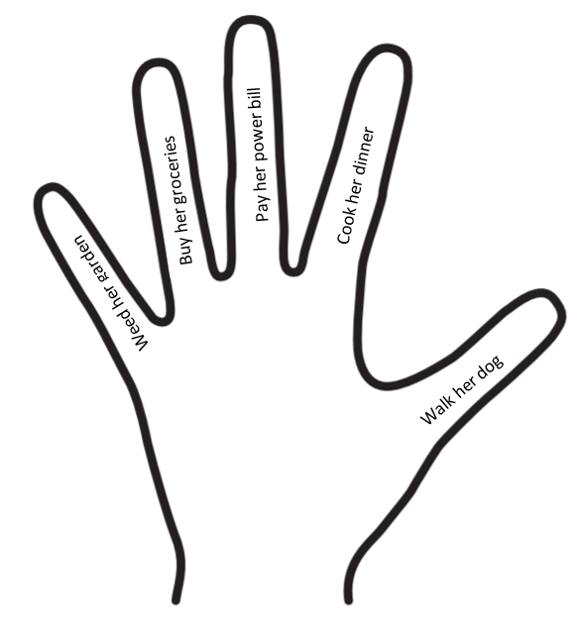

**Big Word of the Day!**

**Philanthropy**: a personal interest in helping others

Activity Sheet

Lend a Helping Hand

Can you think of ways to help others at home, school or the community?

Write or draw things you can do in the boxes.

|  |  |
| --- | --- |
| At Home  Dom clipart 1 » Clipart Station |  |
| At School  Schools clipart 7 » Clipart Station |  |
| In the Community |  |

Assessment Sheet

**Bunnyland Goods and Services**

Chummy wanted to help others. To do so he needed to perform services and supply goods.

Do you think these are pictures of goods or services?

A **GOOD** is a tangible thing that can be bought and sold such superhero costumes and flowers.

A **SERVICE** is an action performed by a person, such as picking cherries or taking care of bees.

|  |  |
| --- | --- |
| Superhero Costume  131 Superhero Coloring Book Illustrations & Clip Art  🞎GOOD 🞎SERVICE | Planting Flowers  46 best ideas for coloring | Spring Coloring Pages For Boys  🞎GOOD 🞎SERVICE |
| Picking Fruit    🞎GOOD 🞎SERVICE | Garden Tool  Hoe clipart black and white 9 » Clipart Station  🞎GOOD 🞎SERVICE |
| Collecting Honeycombs  beekeeper colouring - Clip Art Library  🞎GOOD 🞎SERVICE | Honey    🞎GOOD 🞎SERVICE |

New Children’s Picture Books

|  |  |  |  |  |
| --- | --- | --- | --- | --- |
| **Title** | **Author** | **Copyright & Publisher** | **Econ/PF Concepts** | **Grade Level** |
| ***A Bike Like Sergio’s*** | Boelts, Maribeth | 2018- Candlewick | Money, Poverty, Ethics, Opportunity Cost | K-3 |
| ***Dirt Cheap*** | Huffmann, Mark | 2020- Alfred A..Knopf | Entrepreneurship, Pricing, Earning | PK-2 |
| ***Earl & Starla Want all the Fishy Treats*** | Raymer, Mike | 2021-GCEE | Allocation methods | 2-4 |
| ***Earn It!*** | McLeod, Cinders | 2017 – Penguin | Earning, Money, Jobs, Good & Services | PK-2 |
| ***Fry Bread*** | Noble, Kevin Maillard | 2019- Roaring Brooks Press | Productive Resources | K-2 |
| ***A Gift from Abuela*** | Ruiz, Cecilia | 2018-Candelwich | Money, Exchange Rate,  Choices, Saving, Goals | PK-2 |
| ***Give It!*** | McLeod, Cinders | 2020 – Penguin | Philanthropy | PK-2 |
| ***Home in the Woods*** | Wheeler, Eliza | 2019- Penguin | Poverty, Earning  Productive Resources,  Decision Making  [The Great Depression] | K-3 |
| ***Keeping the City Going*** | Floca, Brian | 2021, Atheneum | Human Resources, Capital Resources, Scarcity  [Pandemic] | PK-2 |
| ***The Oldest Student*** | Hubbard, Rita Lorraine | 2020 – Random  House | Human Capital, Jobs,  Civil Rights, Earning,  Productive Resources | K-3 |
| ***The Oldest Student*** | Hubbard, Rita Lorraine | 2020 – Random  House | Human Capital, Jobs,  Civil Rights, Earning,  Productive Resources | K-3 |
| ***Save It!*** | McLeod, Cinders | 2019 – Penguin | Saving, Money, Choices | PK-2 |
| ***Sloth & Squirrel in a Pickle*** | Mealey, Cathy Ballou | 2021 – Kids Can Press | Jobs, Entrepreneurship, Opportunity Cost | PK-2 |
| ***Someone Builds the Dream*** | Wheeler, Lisa | 2021– Penguin | Productive Resources, Jobs, Specialization, Interdependence | K-3 |
| ***Spend It!*** | McLeod, Cinders | 2019 – Penguin | Spending, Money, Opportunity Cost, Productive Resources | PK-2 |
| ***What is Given from the Heart*** | McKissak, Patricia C. | 2019 – Random House | Human Resources,  Poverty, Philanthropy,  Problem Solving | PK-2 |