Aim: How is the economy affected by shocks? What are the different shocks that can happen to an economy?
Topic: SRAS/AD Graph, “Short Run Aggregate Supply/Demand”

Document #1: Graphing a healthy economy
SRAS/AD together: the point where suppliers are willing to sell/produce products and government, firms, consumers, and foreigners are willing to buy products. Where they intersect equals how much the country produces, or GDP, and the overall price level of that production.
Long Run Aggregate supply (LRAS): Where economy is operating at full employment of resources. Point where, if price level changes, GDP won’t change.
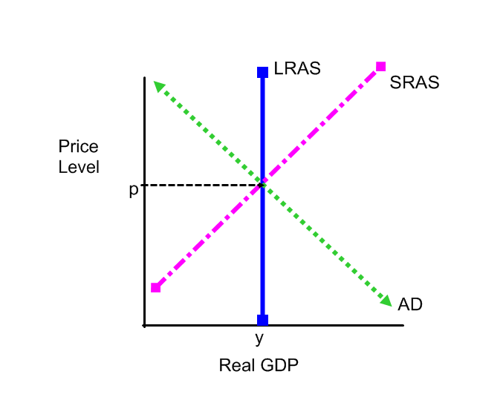

This Graph shows economic equilibrium of a healthy economy – the econmic equilibrium (AS/AD) is on the LRAS curve, or full employment.

Exogenous Shocks – shocks that occur in the economy and change either Aggregate Demand or Aggregate Supply. This causes either AD and/or AS to shift regardless of price level (outside shocks). When these shocks occur, they create inflationary or recessionary conditions or “gaps” in the graph.
Graphing rules:
Reap GDP = y, the first point = y, the second is y1, etc.
Price Level = p, the first point = p, the second = p1.
Always draw a dotted line from your points to the equilibrium to help illustrate what is happening.
Remember, when there is a shift of one curve there is always and accompanying movement along the other curve.
1) How does an equilibrium of SRAS/AD on the LRAS curve illustrate a healthy economy?

2) What are exogenous shocks? Why are they bad?

3) Why must you follow the graphing rules?

Gap #1: Inflationary Gap
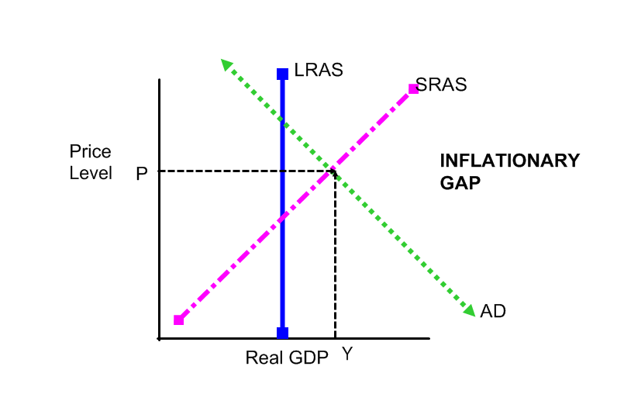
Inflation has two major causes:
a) Demand-Pull Inflation: increased demand increases inflationary pressure.
- economy is producing more than it can handle, too much spending is driving costs up, results in inflation -- higher costs/reduced purchasing power. Output increases if the company is making profits off of the increased prices, however, as the value loses its value, too much money will begin to chase too few products.
b) Cost-Push Inflation: increased input costs to suppliers pushes inflation up. Output may continue to increase, if wages increase with cost-push inflation and the company is making profits off of the increased prices (due to increased costs), however, cost push inflation more commonly results in supply decreasing, creating stagflation pressures – see graph below)
1) How does an increase in aggregate demand create inflationary conditions?

2) What is the difference between demand-pull and cost-push inflation?

3) What are some factors that can shift AD (look at your previous chart) that can cause each of these types of inflation?

4) Which inflation is more dangerous – Demand Pull or Cost Push?

Gap #2: Recessionary Gap
- Caused by a decrease in total spending by one to several of the factors of GDP.
- Output is now below potential and if output is low, so is income.
- Unemployment is also most likely a problem if production is low.

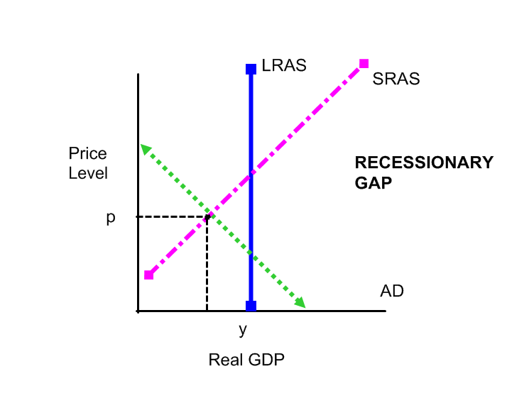
1) What are some factors that will cause a shift in AD to cause a recession?

2) Why will unemployment increase when AD decreases?

Gap #3: Stagflation
- When there is a decrease in resources or an increase in the cost in resources (cost-push inflation), this causes a decrease (shift to the left) in SRAS. A decrease in SRAS will create both recessionary and inflationary conditions.
- This results in a combination of:
1) Cost-Push Inflation: it costs businesses much more to produce goods and services.
2) Decreases output. Businesses cannot produce more.
3) Decreased output and higher costs usually result in unemployment.
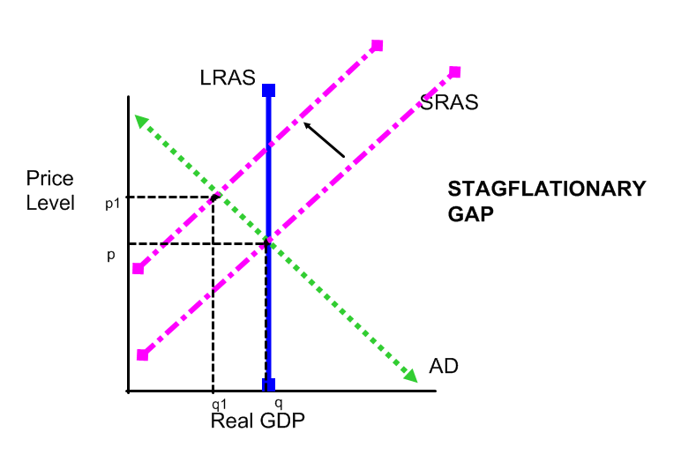

1) Based on the description and the graph of the gap, why is stagflation such a dangerous phenomenon?

2) Why would it be difficult to solve stagflation?

Exogenous Shocks Practice
Exogenous Shocks – shocks that occur in the economy and change either Aggregate Demand or Aggregate Supply.
For each one:
1) draw the graph, labeling everything correctly
2) indicate the change in price level
3) indicate the change in GDP
4) indicate the change in unemployment
5) indicate what state the economy is going through.
Shock #1: Economic Booms in both Japan and Europe result in massive increases in orders for exported goods from the United States.

Shock #2: The Government reduces taxes and increases transfer payments

Shock #3: Fine weather results in the highest corn and wheat yields in 40 years.

Shock #4: Consumer Confidence greatly increases and there is a surge of buying.

Shock #5: While the United States was in the midst of the Great Depression, a foreign power attacked, Congress declared war and more than 1,000,000 soldiers were drafted in the first year while defense spending was increased several times over.

To balance the budget, the federal government cuts Social Security payments by 10 percent and federal aid to education by 20 percent

During a long, slow recovery from a recession, consumers postponed major purchases. Suddenly, they begin to by cars, refrigerators, televisions, and furnaces to replace their failing models.

Shock #6: Businesses greatly reduce spending on their inventories.

Shock #7: Bank loans freeze up.

Shock #8: New Environmental standards raise the average cost of autos and trucks 5 percent.

