Understanding the Circular Flow of the Macroeconomy

«?»«». Wiar'e J 11.1. 11^1, .IJ...IU..I,1_1..._J^_..J .iun_iJ.JliUi U I "-i''"it'-''"--'"''^"'' ~— '■

Figure 10,1

The Circular Flow of Resources, Goods, Services and Money Payments

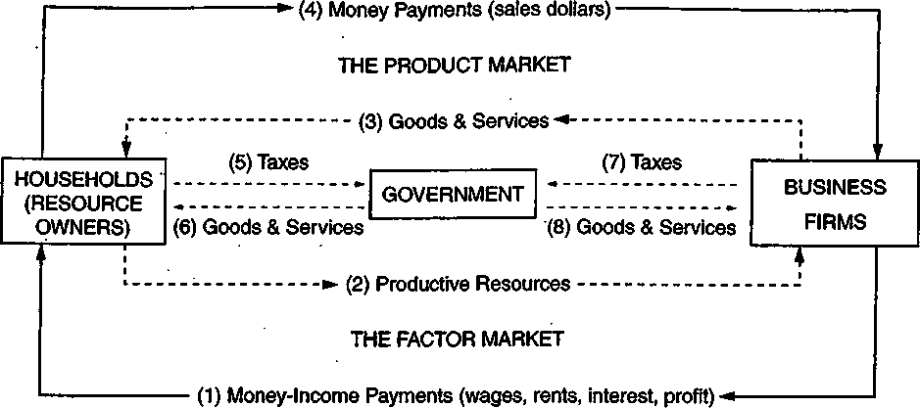

Understanding the Circular Flow of the Macroeconomy

Part A

Each of the flows in the circular flow diagram in Figure 10.1 is numbered. Identify which number matches the transaction described in the statements below. Consider only the first transaction — not the return flow.

1. David buys a CD at the local store for $9.99.
2. Emily earns $6.50 per hour entering data at the music conservatory.
3. Maria pays her federal income tax.
4. Jagdish receives $15,000 in profits from his half-ownership of a coffee shop.
5. Keisha makes decorative pillows that she sells for $30.00.
6. Mammoth Toys Inc. hires 100 new employees.
7. The National Park Service opens two new campgrounds in Yellowstone National Park.

Parts

Write T if the statement is true and F if the statement is false.

1. Money flows are clockwise.
2. Goods and services flows are clockwise.
3. The resource market determines the price per acre of farmland.
4. The product market determines the price of a computer.
5. Firms sell resources in the resource markets.
6. Government buys resomces and households sell resources.
7. Government buys products, and firms sell products.
8. The product market determines the salary of the C.E.O. of a firm.
9. The resource market determines the price of soda.
10. The resource market determines the price of soda-bottling equipment.

Advanced Placement Economics Macroeconomics: Student Activities

National Council on Economic Education, New York, N.Y.



LESSON !■ ACTIVITY. 10 ,,

Part A

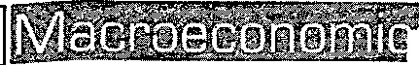

Each of the flows in the circular flow diagram in Figure 10.1 is numbered. Identify which number matches the transaction described in the statements below. Consider only the first transaction — not the return flow.

1. David buys a CD at the local store for $9.99.

4

1. Emily earns $6.50 per hour entering data at the music conservatory.
2. Maria pays her federal income tax.
3. Jagdish receives $15,000 in profits from his half-ownership of a coffee shop. '
4. Keisha makes decorative pillows that she sells for $30.00.
5. Mammoth Toys Inc. hires 100 new employees.
6. The National Park Service opens two new campgrounds in Yellowstone National Park.

PartB

Write T if the statement is true and F if the statement is false.

1. Money flows are clockwise. 'I
2. Goods and services flows are clockwise.
3. The resource market determines the price per acre of farmland. I

i

1. The product market determines the price of a computer.

\

1. Firms sell resources in the resource markets. _
2. Government buys resources and households sell resources. _ T"
3. Government buys products, and firms sell products. :iL
4. The product market determines the salary of the C.E.O. of a firm. IF
5. The resource market determines the price of soda. ^
6. The resource market determines the price of soda-bottling equipment. _

Advanced Placement Economics Macroeconomics: Student Activities © National Council on Economic Education* New York, N.Y.