Aim: Are there exceptions to the law of demand?
Topic: Elasticity

Document #1: Price Elasticity of Demand
The Law of Demand tells us that: “all else equal, when the price of a particular good falls, the quantity demanded for that good rises and vice versa.” But what it fails to answer for us is: “by how much?” Will it be a relatively large increase or decrease in quantity demanded or will it be almost negligible? In other words, it is important to measure how sensitive consumers are to a change in the price of this good.
1) What doesn’t the law of demand tell us?

2) Why do you think it is important to know “consumer sensitivity” of a product?

Document #2: Consumer Sensitivity is a concept called Elasticity of Demand. It measures the sensitivity of consumption to an external change. If a product is elastic, then it is sensitive to change – demand stretches as price stretches. If a product is inelastic, the demand does not stretch along with the price.
Elasticity Rules:
There are two formulas for determining elasticity:
Formula #1:
Ed (elasticity of demand): (%change in quantity demanded of a good)/(%change in the price of good x)

Formula #2:
Ed: Total Revenue = Price x Quantity Demanded

*Elastic = Percentage change in quantity demanded greater than percentage change in price - answer is greater than or equal to 1
*Inelastic = Percentage change in quantity demanded is less than percentage change in price
*Unit Elastic = Percentage change in quantity demanded is equal to the percentage change in price it is equal to 1 (a 1:1 ratio)

Formula #1 expanded:
Ed (elasticity of demand): (%change in quantity demanded of a good)/(%change in the price of good x)
If Ed is greater or equal to one then the product is said to be elastic
If Ed is less than one then the product is said to be inelastic
Examples: The price of a computer increases by 10 percent and we observe a 20 percent decrease in quantity demanded, then using the formula:
Ed = (-20%)/(+10%) = -2 or 2. It is higher than one, so that means this good is price elastic – The responsiveness of the consumers exceeded, in percentage terms, the initial change in the price.
Example #2: The price of gasoline increases by 10 percent and we observe a 5 percent decrease in quantity demanded. Using the above the formula:
Ed = (5%)/(10%) = ½ -- Ed is less than 1 so it is said to “price inelastic.” -- the initial change in price exceeded, in percentage terms, the responsiveness of the consumer.
1) Why do you divide the percent change in demand of a good by the percent change in price of a good to show elasticity?

Formula #2:
Ed: Total Revenue = Price x Quantity Demanded
A seller might think, “If I continue to raise the price, my total revenues must continue to rise.” A student of microeconomics knows that this is a flawed logic, because quantity demanded falls when the price rises, making the impact of total revenue uncertain.
If price (P) increases by 20 percent and quantity demanded (Q) decreases by 20 percent, total revenue (TR) will stay the same. This is called a unit elastic or proportional change.
If P increases by 20 percent and Q decreases by 25 percent, then TR will decrease. This is called an elastic, or greater than proportional change.
If P increases by 20 percent and Q decreases by 10 percent, then TR will increase. This is called an inelastic or less than proportional change.
So if Total Revenue increases, % change in Ed would be less than 1 or inelastic.
If Total Revenue decreases or stays the same, the % change in Ed would be elastic or unit elastic (stays the same).
1) If price increases but quantity decreases by an equal or greater percentage, why would this product be elastic?

2) If price increases and quantity decreases by a smaller percentage, why would this product be inelastic?

Document #3: What does elasticity look like?
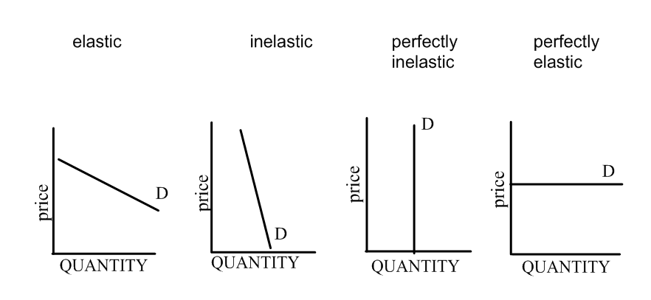
For each graph, explain why each graph is a varying degree of elasticity

Factors that can affect elasticity of a product
1) Number of Substitute
a. If the price of good x increases, and many substitutes exist, the decrease in quantity demanded can be quite elastic. The reverse is true.
b. This is also known as Cross-Price Elasticity
c. % change in good x/%change in good y
Q: Name a cross-price elastic product and a cross price inelastic product?

2) Proportion of Income
a. If the price of a good increases, the consumer loses purchasing power. If that good takes up a large proportion of the consumer’s income, he greatly feels the pinch of the income effect, and his responsiveness might be significant.
b. This is also known as Income Elasticity
c. If the good is elastic then it is a luxury.
d. If the good is inelastic then it is a necessity
e. (%change in good x)/(%change in income)
Q: Name an income elastic product (luxury) and an income inelastic product (necessity)

c) Time
a. Consumers faced by a rising price are usually fairly resourceful in their ability to find a way of decreasing the quantity demanded of a good.

So how does this affect policy?
Excise Taxes: taxes on production. These taxes have two purposes: raise government revenue and/or deter behavior.
1) What would happen if an excise tax is placed on an elastic product?

2) What would happen if an excise tax is placed on an inelastic product?

Can Supply be affected by Income Elasticity?
Yes, but again, the elasticity varies. Elasticity of Supply = add in quantity supplied/(% price)
Elasticity of Supply depends on costs of factors of production.

Practice Questions
1. If the price of corn rises 5 percent and the quantity of demanded for corn falls 1 percent, then  a. Ed = 5 and demand is price elastic  b. Ed = 1/5 and demand is price elastic  c. Ed = 5 and demand is price is inelastic  d. Ed = 1/5 and demand is price inelastic  e. Ed = 5 and corn is a luxury product | 2. A small business estimates price elasticity for the product to be 3. To raise total revenue  a. decrease price as demand is elastic  b. decrease price as demand is inelastic  c. increase price as demand is elastic  d. increase price as demand is inelastic  e. do nothing; they are already maximizing total revenue

