Birdie the Entrepreneur

Introduction: Birdie, wants to make money to buy a soccer ball. However, she does not seem to understand that an entrepreneur needs to organize and utilize productive resources efficiently to make a profit.

Time Required: 25-30 minutes.

Grade Level: 4-7

Materials:
- Copy of Dirt Cheap by Mark Hoffmann
- Visual 1 - Productive Resources Poster
- Visual 2- Productive Resources Web
- Activity Sheet – Productive Resources Web
- Writing tools

Objectives:
- The student will explain how entrepreneurs use productive resources to produce goods and services.
- The student will use a graphic organizer to communicate information.

Procedure:
- Introduce the lesson by asking the students if they have ever heard of the word entrepreneur. Define entrepreneur as a person who combines productive resources to produce goods and services that they expect to sell for a profit.
- Share with the students that Birdie, the main character in the book Dirt Cheap, wanted to be an entrepreneur and start her own business to make money to buy a soccer ball. However, she did not understand that she needed the necessary tools and skills to be successful.
- Display Visual 1- Productive Resources Poster.
- Review the definitions using the poster as a visual aid. Note that the Birdie is a human resource, the wheelbarrow is a capital resource, and the dirt is a natural resource.
- Display Visual 2 - Productive Resources Web. Tell the students to pretend that Birdie was in the class and was learning how to be an entrepreneur. She now wants to start a new business. If she were to fill in a Productive Resources Web, this is what it might look like.
- Review the contents of the visual noting the name of the business, the name of the entrepreneur, and the productive resources needed to create the product.

- Distribute the Productive Resources Activity Sheet and writing tools. Tell the students that they are to pretend to be entrepreneurs wishing to provide a good or a service so they can make a profit. (Possible goods and services could include a lemonade stand, yard care service, pet sitting, greeting card production, delivery services, jewelry making, and tutoring.) They are to come up with a good or service, provide a catchy product name, and fill in the web graphic with correct examples of human, capital and natural resources.
- Encourage students to share their completed work with the class.

Visual 1-
Productive Resources Poster

- Capital Resources are manmade resources such tools, buildings, and vehicles used in production. The wheelbarrow is a capital resource.

- Natural Resources are gifts of nature. The top soil in the wheelbarrow is an example of a natural resource.

- Human Resources are people who work. Birdie would be an example of human resources.

- Goods are tangible things such as food, clothes, and cars. Birdies glasses and boots are examples of goods.

- Services are physically intangible things such as medical care, haircuts, and education. Yard work is an example of a service.

- Entrepreneurs are people who organize, operate, and assume the risk for a business venture. Birdie would like to be an entrepreneur, but she does not know how.

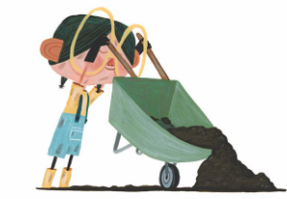

Visual 2-

~Productive Resources Web~

Business: Terrific Top Soil Human Resource:
Entrepreneur: Birdie 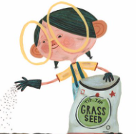

Dirt Digger & Bagger

Good/Service:
Product

Capital Resources:
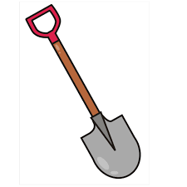
Terrific Top Soil
Shovel

Natural Resources:

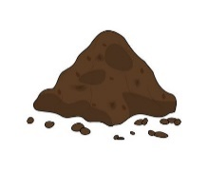
Dirt
Activity Sheet-
~Productive Resources Web~

Business:
Entrepreneur:
Human Resource:

Good/Service:
Product

Capital Resources:

Natural Resources:

