Merci Suarez Changes Gears
Goods & Services
Merci and her brother are attending Seaward Pines Academy on a special scholarship.
Their father has agreed to barter his skills as a painter and maintainace person in exchange for the tuition the school charges its students. He is exchanging his work and materials for his children’s education.

A GOOD is an object that can be touched, like a paint brush or hammer.

A SERVICE is an action performed by a person, such as painting a wall or repairing a broken stair step.

Look at each item. Circle the word GOOD if you think it is a good or SERVICE if you think it is a service.

On the back of the paper, draw and lable four more examples of GOODS and SEVICES. Extra credit if they are represented in the book.

Soccer Ball  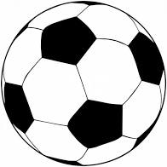  GOOD SERVICE | Bicycle  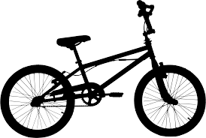  GOOD SERVICE | Mentoring  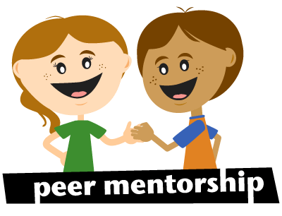  GOOD SERVICE
Painting Walls  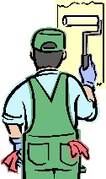  GOOD SERVICE | Selling Baked Goods  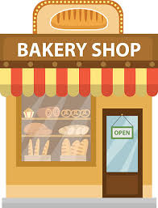  GOOD SERVICE | Chemistry Book  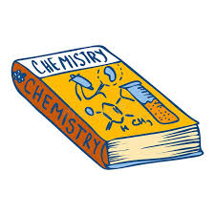  GOOD SERVICE
Ladder  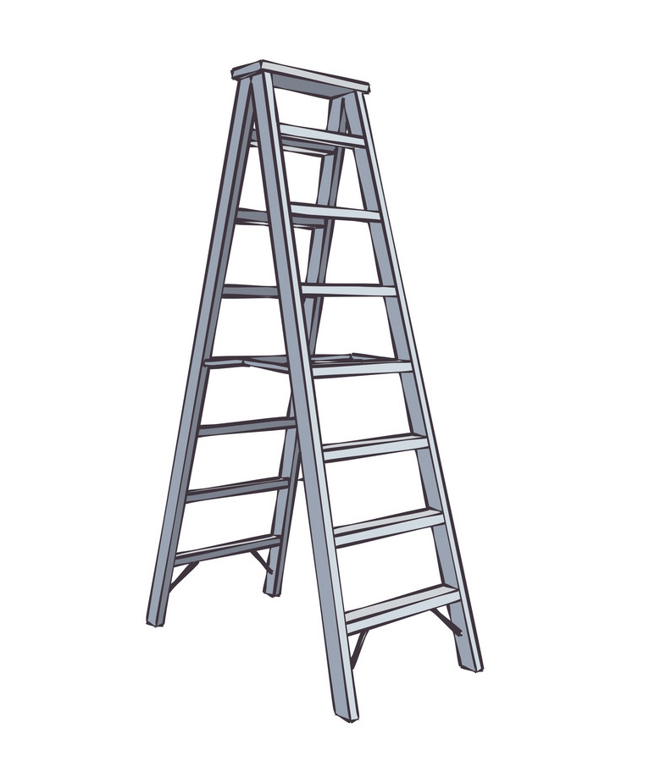  GOOD SERVICE | Van  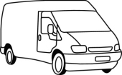  GOOD SERVICE | Babysitting  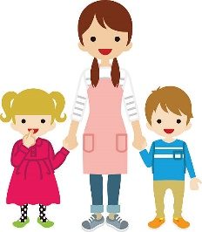  GOOD SERVICE

