Resources for The History of Social Security Webinar

Mentimeter
https://www.menti.com/5iy6net6d5

Peter G. Peterson Foundation – Charts
https://www.pgpf.org/resource-library/search?f%5B0%5D=field_type%3A176

Political Cartoons - Understanding Fiscal Responsibility - The History of Social Security Direct Instruction Lesson
https://econedlink.org/resources/the-history-of-social-security/

Lesson - Understanding Fiscal Responsibility - The History of Social Security Inquiry Based Lesson
https://econedlink.org/resources/the-history-of-social-security/

Inquiry Based Learning
- Prodigy Learning https://www.prodigygame.com/main-en/blog/inquiry-based-learning-definition-benefits-strategies
- Edutopia : https://www.edutopia.org/blog/what-heck-inquiry-based-learning-heather-wolpert-gawron

Two Cents - Will Social Security Be Around for Millennials?
https://www.youtube.com/watch?v=gttUS9tKOes

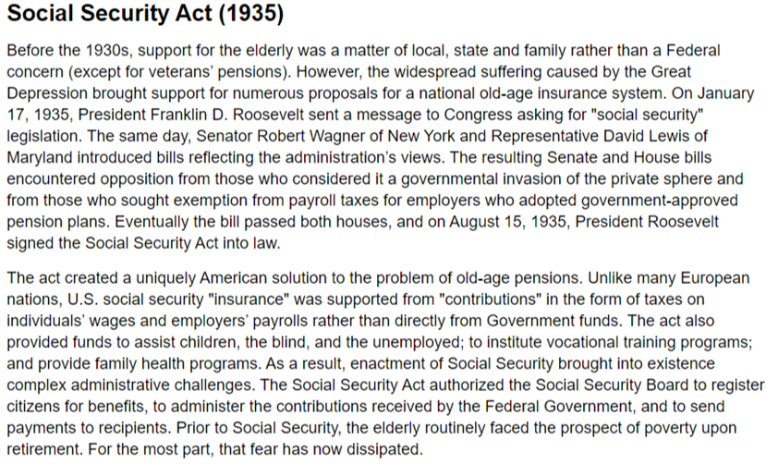

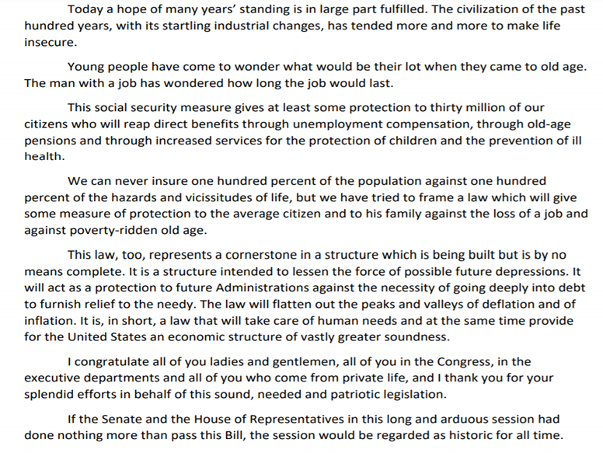
FDR’s Speech

