AIM: How is the health of the economy measured?
TOPIC: GDP – Gross Domestic Product

Gross Domestic Product (or GDP): This is the main statistic for measuring the performance of the economy. Gross Domestic Product measures the dollar value of production within the nation’s borders (both foreign and domestic producers). The more that is produced = a healthier economy.

Expenditure Approach to calculating GDP:
The expenditures approach calculates the total production within the country by adding up the four components:
GDP = C+I+G+X
C = Consumer Spending all of the goods and services sold to households
I = Investment in capital by firms
G = Government purchases of goods and services)
X = Net exports (exports – imports)

***only the initial purchases and costs of productions of these items are counted***

1) What does GDP measure? Why is this an important indicator?

- For C+I+G+X, why is it important that each of these are measured?

3) Why does GDP include foreign businesses producing in America?

4) Why are only the initial sales/costs of production counted?

- How should we use the GDP number to determine the health of our country?

6) Why might GDP be considered the most important indicator?

Part Two: Items not counted in GDP
1) Secondhand sales
2) Purely financial transactions (such as stocks)
3) Intermediate sales - example: tomatoes for ketchup.
4) Underground economy/blackmarket
5) Transfer payments from government to people (i.e. - social security, etc.)
6) Self service, non-market activity

For each item, why should it not be counted?

Part III: Secondary Approaches to GDP
Task: Read the Secondary approaches to using GDP and GDP worksheet and answer the 6 questions below
Secondary approaches to using GDP to calculate a nation’s production:
I. Nominal v. Real GDP
Nominal GDP: "current dollar GDP" - the amount produced (GDP) not taking inflation into account.
Real GDP: "constant dollar GDP" - GDP adjusted for inflation.
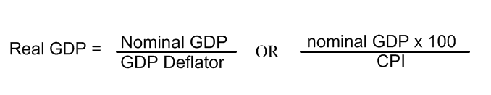
*GDP deflator is explained below

II. Output Growth
Output growth measures the percentage change in production growth (GDP) from one period (year or quarter to the next)
- high percentage = growth
- low percentage = slow growth
- negative percentage = negative growth - two consecutive quarters of negative growth = recession
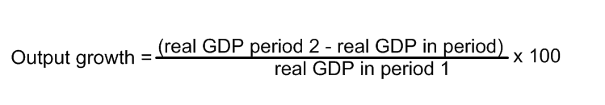

III. Gross National Product (GNP)
This is similar to GDP except GNP includes production by American workers abroad and excludes production by foreign workers in America. It is the dollar value produced by a country’s citizens.

IV. GDP per Capita:
GDP per capita measures how much is produced per person within a country’s borders and represents the average value of all of the goods produced in the economy. This equates to the Standard of Living of a nation: when you divide how much is produced/earned divided by the population – this gives the basic standard of living (how well people live): the average amount spent on goods/services or the average income.
Formula = Real GDP divided by Population.

V The Income Approach/Personal Income Approach
Approach (National Income – NI): Based on the circular flow model, if you add up all of the spending, it would equal all of the income -- wages, rent, interest and profit, minus depreciation and business taxes would also lead to national income, or GDP. GDP can be calculated from income by taking the income earned by households and profits earned by firms after subtracting depreciation and indirect taxes from the list below:
The US "National Income and Expenditure Accounts" divide incomes into five categories:
1) Wages, salaries, and supplementary labor income
2) Corporate profits
3) Interest and miscellaneous investment income
4) Farmers’ income
5) Income from non-farm unincorporated businesses

VI: GDP Deflator:
GDP can also be used to determine inflation:
GDP Deflator measures the level of price change in the economy based on GDP.
Nominal GDP is “deflated” to create Real GDP
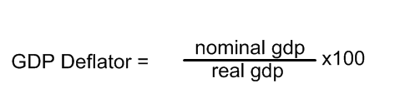

1) What is the difference between Real and Nominal GDP? Why do we need to make a distinction between the two?

2) What is output growth? Why is it important to calculate to show the health of an economy?

3) How is GNP different from GDP?

4) What is “Standard of living?” Why is it important to measure it? How does Real GDP per capita help measure standard of living?

5) How can we use National Income and Personal income to measure production of a country? How can the GDP be calculated using this approach?

6) How can GDP Deflator be used to calculate inflation? What is the difference between GDP Deflator and the CPI?

