Student Loans and Interest Rates
If debt in your life is unavoidable, student loans are among the best debts to have. Although it can be scary to start your adult life with debt, financing a good education should be seen as an investment. Having a college degree can help you start with a better and higher paying job than you would have otherwise. And for many people, a college education is impossible to obtain without borrowing money to pay for it.

Student loans come in many shapes and sizes, and the regulations for them can be different as well. There are several types of education loans for which you may be eligible.
Stafford and Perkins Loans are federal loans given directly to the student. This type of loan, which is funded with government money, comes with low interest rates and favorable repayment options. It also requires no credit check (how loan worthy you are) or collateral (if you fail to repay your loan, the institution can claim your property or assets). They can be consolidated upon graduation.

PLUS loans, originally called Parent Loans for Undergraduate Students, were created so parents could help fund their children’s educations. Now, parents may take out Parent PLUS loans and graduate students may use Grad PLUS loans.
Some students may also be eligible for private loans or health professional loans, depending on their credit standing and area of study respectively.
When you take out a loan, you are paying for the principal (the amount- what is called the balance- of a loan) plus an interest rate which is applied to the loan (a percentage of the loan that must be paid back). So you owe the balance plus the interest – the interest is how the banks make money, which is why they loan it to you. The payments made are monthly with the interest from the original principal broken into the monthly payments. Be careful of loans in which you are paying more of the interest in the beginning and the principal in the end (this takes longer to pay, although for some types of loans, this might be unavoidable). When paying your loan back, try to add more than the minimum payment every month as the extra payment goes directly toward reducing your principal balance and helping you pay your bill faster.
Regardless of which loan you take, you must make sure to get a fixed interest rate as opposed to a variable interest rate. A fixed interest rate remains the same for the life if the loan whereas a variable interest rate can change whenever the banks decide to change interest rates. Banks most often change interest rates due to inflation. Inflation erodes purchasing power. When this happens, lenders lose money because they are being paid back with inflated dollars or dollars that are worth less. In order to protect themselves, banks will raise the interest rate in anticipation of inflation (this will be outlined in Fisher’s Hypothesis later in the lesson). However, if you have a fixed interest rate, your rate will remain the same for the duration of the loan. It is true that interest rates can decrease, however inflation occurring is more of a trend over a longer period of time.
Define:
Loan
Public Loan
Private Loan
Balance
Interest Rate
Minimum Payment
Fixed Interest Rate
Variable Interest Rate

- Why are fixed interest rates better than variable interest rates?

Below is a list of student loans: look over the list and see which ones initially might be good for you and your family. Read up on them further at home.

Types of Student Loans
Stafford Loans
Stafford Loans are more common than Perkins Loans, the other type of federal student loans. Money for these loans comes directly from the federal government in a program called the Federal Direct Student Loan Program (FDSLP).
There are two types of Stafford Loans: subsidized and unsubsidized. The type helps determine your interest rate and maximum loan amount.
Subsidized Stafford Loans
If your loan is subsidized, you won’t be responsible for making any payments until after you graduate. Your interest rate typically should be at or below 6.8 percent. The government pays your interest for you while you’re in school.
Subsidized loans are reserved for students who can demonstrate a financial hardship. Most go to students whose families’ annual incomes are below $50,000.
If you’re an undergraduate, the maximum annual amount of a subsidized loan depends on your year in school. You cannot accrue more than $23,000 in subsidized Stafford Loans throughout your undergraduate studies.
If you’re a graduate student or medical student, your yearly loan amount is capped at $8,500. Graduate students and medical students can’t borrow more than $65,500 in total, including their undergraduate subsidized loans.
Unsubsidized Stafford Loans
If you have an unsubsidized loan, you’re responsible for paying off all the interest. Interest builds up at a fixed rate of 4.66 percent while you’re in school, but payments are typically deferred – or postponed – until after you graduate. All students are eligible for this type of loan.
Your annual Stafford Loan limit ranges from $5,500 to $12,500. You are eligible for a larger loan if you are later in your education or if you’re financially independent. If you’re financially dependent but your parents are ineligible for Parent PLUS loans, you’re permitted the same maximum loans as if you were independent.
These loans caps are for both subsidized and unsubsidized loans combined. This means that if you’re given a large subsidized loan, you are only eligible for a smaller unsubsidized loan. Likewise, if you have a small subsidized Stafford Loan or none at all, your unsubsidized loan can be larger.
If you’re a graduate student, you have a higher annual limit of $20,500. In total, your undergraduate and graduate Stafford Loans cannot exceed $138,500.
Or if you’re a medical student, you have the highest limits. You may borrow up to $40,500 annually and $224,000 in total.
To apply for a Stafford loan, complete the Free Application for Federal Student Aid (FAFSA).
Perkins Loans
Perkins Loans are more desirable than Stafford Loans and have more stringent eligibility rules. Perkins Loans have a fixed interest rate of 5 percent. They are all subsidized, so the government pays any interest accrued while you’re in school and for short period after you graduate.
Because of their favorable terms, Perkins Loans are reserved for students who show exceptional financial need.
These loans are funded by the government but disbursed by each individual college or university. The federal government distributes a limited amount of funds to each school, and the school determines which students to lend to.
As with Stafford Loans, students can only borrow a certain amount through Perkins Loans. Eligible undergraduates may borrow up to $5,500 in Perkins Loans annually, for a total of 27,500.
Graduate students may borrow up to $8,000 annually. The total cap is $60,000 and is based on both undergraduate and graduate Perkins Loans.
PLUS Loans
PLUS loans are available for both parents and graduate students. Parent PLUS loans are for parents of dependent undergraduate students, and Grad PLUS loans are for graduate students themselves.
As with other education loans, PLUS loans are funded directly by the federal government. But unlike traditional student loans, they have no maximum amounts and can be used to cover any education costs not covered by other financial aid. They have a fixed interest rate of 7.21 percent.
Private Education Loans
Private education loans, also called alternative education loans, are an option for students and parents when other sources of financial aid do not fully cover the cost of school.
As the name suggests, these loans are provided by private lenders and do not use government funding. Because of this, private education loans more closely resemble personal loans than student and parent loans.
Your eligibility and interest rate depend on your credit history. Your interest rate is typically higher than with federally guaranteed education loans but lower than with other debts like credit card debt.
Specific borrowing terms may vary by lender.
Health Professions Student Loans
Specialized student loans exist for students studying specific areas of medicine such as nursing, sports medicine or veterinary medicine. Each loan has its own requirements about accepted areas of study and financial need.
How to Get Your Student Loans Forgiven: Three Paths
Student loan forgiveness is not easy to achieve, but there are three primary ways to get your student loan forgiven: one based on what type of career you choose (Public Service Loan Forgiveness), one based on how many years you make on-time payments on a qualifying repayment plan, and one based on your ability to work and meet your loan obligations (student loan discharge). The first two are available for Federal student loans only and the last one is achievable for private student loans, as well.
Public Service Student Loans Forgiveness Program (PSLF)
Public Service Loan Forgiveness was created by the College Cost Reduction and Access Act of 2007 to encourage highly-qualified graduates to pursue careers in the public service sector, while lessoning the burden of student loans. In order to receive loan forgiveness under this program, you must be working in a public service job, consolidate your federal student loans to a qualifying repayment program, and make 10 years of on-time payments.
To qualify for this program, you must be making payments under the income-contingent, income-based, pay-as-you-earn or standard repayment plan.
As the program was created in 2007, no one has yet received loan forgiveness under this plan. The first group to qualify for Public Service Loan Forgiveness will meet the final requirement in 2017.
This forgiveness option applies solely to federal student loans. Private student loans are not eligible for Public Service Loan Forgiveness.
Career fields that qualify include education, law enforcement, health, public law, and veterinary medicine. For more information on this path to loan forgiveness, visit Public Service Loan Forgiveness.

Loan Forgiveness after 20 or 25 Years of On-Time Payments
The second kind of loan forgiveness is based on how long you make on-time payments, under a qualifying repayment plan. You do not need to be working in a specific career field to qualify for loan forgiveness based on your repayment history.
To qualify for loan forgiveness after 20 years of on-time payments, you must be enrolled in the pay-as-you-earn repayment plan during your 20 years of payments. This repayment plan will generally offer you the lowest monthly payment. To enroll in this repayment plan, you must demonstrate financial hardship. You may remain in the program, however, after the hardship has resolved.
To qualify for loan forgiveness after 25 years of on-time payments, you must be enrolled in the income-contingent, or income-based repayment plans during your 25 years of payments. Forgiveness based on 20 or 25 years of on-time payments is only available to Federal Student loans. Private student loans do not qualify.

Student Loan Discharge
There’s on additional way to achieve student loans forgiveness which is called discharge. Discharge is granted under very rare circumstances, like permanent disability or death. It is generally awarded by a judge and can apply to both Federal and private student loans. Read more about the differences between forgiveness and discharge.

AIM: How can we measure the health of the economy?
TOPIC: Indicator #2: Price Stability and the Inflation Rate

Document #1: Introduction to Price Stability and the Inflation Rate
Purchasing power is the consumers’ ability to purchase goods, based on the income of the consumer and the price of the goods. Having stable prices is important to a healthy economy, as it allows for a steady purchasing power of consumers. Price stability measures the change in the price level. The price level measures the average change over time in the prices paid by urban consumers for a market basket (collection of goods) of consumer goods and services (how much it would cost today, for last year’s goods). This is also known as the Consumer Price Index. The rate of change of one period to another period is known as the inflation rate. When inflation increases or decreases this is referred to as a change in the price level.
The CPI is calculated by dividing the total cost of the market basket this period by the total cost of the base period x 100.

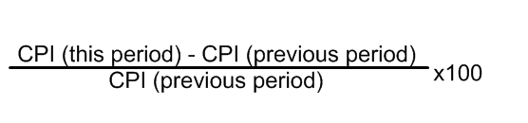
*AP Hint: The Base Period CPI will always be 100 because it is being divided against itself.
The inflation rate is then calculated by comparing the change between this period and the base period, and then dividing the base period x 100.

Document #2: What causes inflation?
There are two main causes of inflation: Demand-Pull Inflation and Cost-Push Inflation. Demand Pull inflation is more commonly known as “too much money chasing too few products.” In this case, people are increasing their demand for products, without the production of the products increasing. This increase in demand (and the willingness to pay more for the product) raises the price level (see graphical analysis). The other, more dangerous kind of inflation is cost-push inflation. In this case, there has been a negative supply-shock (such as input costs increasing), forcing suppliers to decrease supply. As supply decreases, less is produced at a higher price. However, adding to this situation is that unemployment will usually accompany a decrease in production. This phenomenon is known as stagflation – a period of both high unemployment and high inflation (prices).

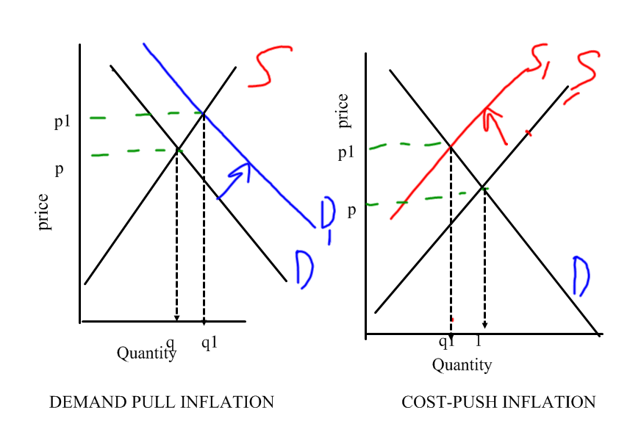

Task 1: Based on Documents 1 and 2 define the following words
Price Level:

Market Basket:

Index:

Base Year:

Consumer Price Index:

Inflation Rate:

Demand Pull Inflation:

Cost Push Inflation:

Questions:
- What is price stability? Why would the government think this is an important indicator of economic health?

- How is price stability measured?

- Why do you think the government focuses on urban consumer goods (including imports) to measure inflation?

- Why is cost push inflation more dangerous than demand pull inflation?

- Complete the inflation activity (page 9 of packet)

Document 3: The effects of inflation
Inflation has many affects, namely changing the “real” of money – our true purchasing power. The wages, income and interest rates we receive are known as “nominal” – not adjusted for inflation. However, as price increases, our purchasing power changes – the change to what we can actually buy or our actual rate of return on interest adjusted for change to the price level is called real. As the price level increases, this can potentially decrease our real purchasing power, if our nominal purchasing power does not increase with inflation.

Below is a list of the mostly negative (but a few positive effects) of inflation:
- Effects of Inflation:
- Erodes financial wealth/ purchasing power
- Higher prices sometimes equal higher salaries (or vice-versa)
- Savings are discouraged/eroded (real interest rate decreases – real interest rate = nominal rate – inflation)
- Menu costs – resources are misallocated with rising prices/ the real cost of changing listed prices
- Inflation tax – wealth is redistributed from lenders to borrowers (borrowers pay back in inflated dollars, really pay back less).
- Shoe-leather costs: opportunity cost of time and effort of people trying to find cheaper prices
- Unite of account costs: arise from the way inflation makes money a less reliable unit of measurement (for taxes, profit, etc.)
- Fisher’s Hypothesis – if inflation is expected, banks don’t lose money because they increase the interest rate
*nominal interest rate = real interest rate + expected inflation
- International effects:
- Depreciation of currency – currency is worth less
- Countries don’t invest in countries with inflation
*Biggest borrower = American Government
- Real wage (income) vs. nominal wage (income)
- Nominal wage is the raw wage that you make
- Real wage is your real purchasing power/adjusted(indexed) wage that you make after inflation
- If the inflation rate increases outpace increases in nominal wage, the real wage decreases.
- Real interest vs. nominal interest rate
The nominal interest rate is the raw/unadjusted interest rate
The real interest rate is the actual rate of interest/rate of return on your investments so for borrowers, real rate = nominal rate – inflation rate

However, banks can protect against inflation, by calculating the real rate of return against expected inflation and increase the nominal rate
•real rate + expected rate = nominal rate – inflation rate
***This is known as Fischer’s Hypothesis

- Expected vs. Unexpected Inflation
Expected Inflation: When the government, business and people expect inflation and prepare for it in their budgets/loans/savings

Unanticipated/unexpected Inflation: when government, businesses, and people do not expect inflation to increase and do not prepare for it in their budgets/ loans/savings

- Effects on bond prices
Bonds are “IOU’s” from the government, corporations and the Federal Reserve. People give these entities loans and are paid back after a certain period of time (called a maturity date) with the principal (initial amount) plus a yearly compounded interest. For example, a $1,000 5% bond over the course of 5 years = year 1: 1,050; year 2: 5% interest of$1,050 = $1,152 and so forth up until year 5.
For bonds, assume 1) bonds’ interest rate is non-variable (does not change); 2) bonds are traded like stocks – they can increase and decrease in value. If there is inflation, due to Fischer’s Hypothesis, with inflation, the interest rate will increase. That means (previously issued) bonds are worth less (since the new bonds will be at a higher interest rate). If inflation decreases (and thus interest rate decreases), the (previously issued) bonds are worth more since their interest rate will be higher than new bonds. So:
Inflation increases: (previously issued) bonds decrease in value
Inflation decreases: (previously issued) bonds increase in value.

Questions: Answer the following questions in your notebooks
- Create a T-Chart of who is helped and hurt by inflation

- What is the difference between real and nominal interest rates? Why is it important to differentiate between the two?

- Why is unexpected inflation worse than expected inflation?

- How can expected inflation be bad, too?

- How do banks use the Fischer Hypothesis to protect themselves against inflation?

- What are bonds? Why might they be attractive investment options? How are they affected by inflation?

- Why is it important to make sure your investments (even savings accounts) have compound interest?

Task 2: Read over document three, the effects of inflation and then complete the effects of inflation exercises on page 11 and 12 of packet

