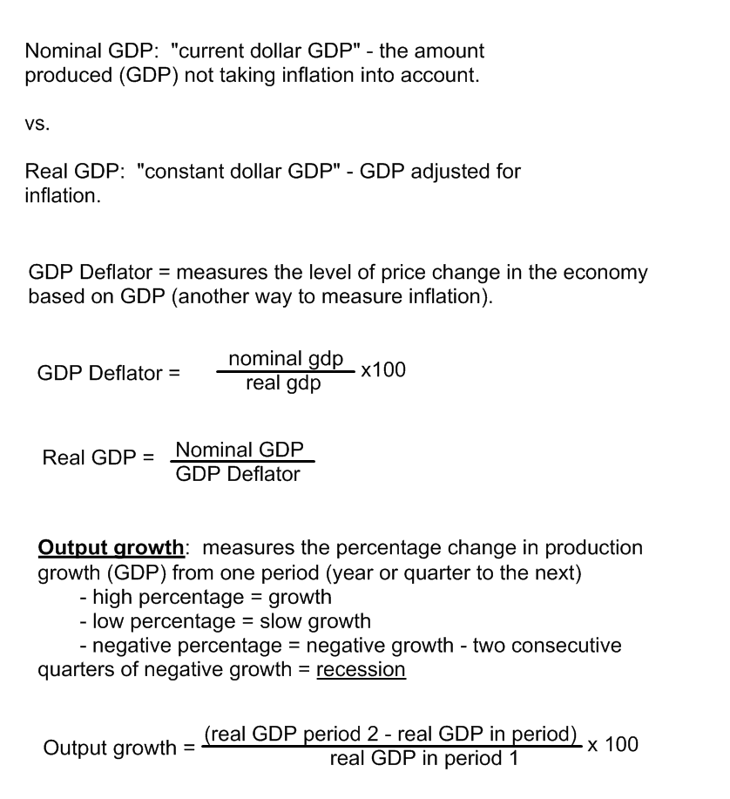
GDP per capita: Total Real GDP divided by the population. Represents the average value of all of the goods produced in the economy. This is used to show a nation’s standard of living (how well people live).

