Business Distance Learning Project
Part I: Initial Analysis
1- Managers use many types of resources. For information resources, include at least one link to a source of information about your given industry (Ex: an article about growth/decline in your industry, earning reports of a competitor, any regulations relevant to your business)
2- Create a mission statement for your organization. Feel free to look at the mission statements of major corporations (available on their websites) as examples for this activity.
Part II: Human Resources
Describe the human resources used by your business. What are the number of employees require? The qualifications and skills for each position? Will jobs be full or part time?
Part III: Management Structure
Below are three types of firm structures. Look over the three firm structures then
1- Choose which type of firm will your company be and why?
2- Give detailed explanation of why you think this type of firm structure is best for company and your own style of management
3- Which will be best for your employees? Is what is best for your employees best for the company?
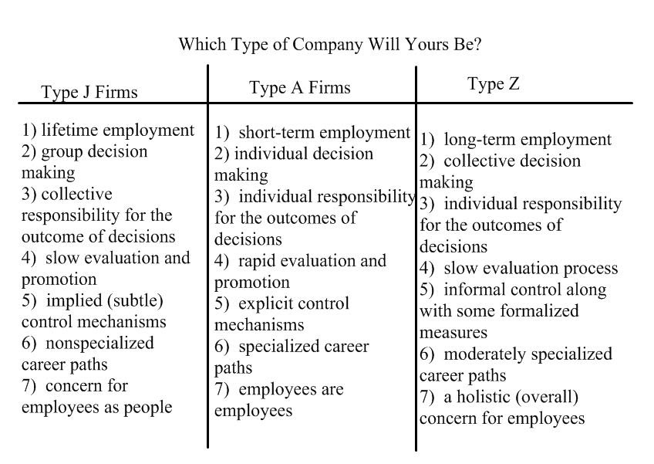

Part IV: Marketing
1- Write a paragraph describing your target market. Remember, your target market CANNOT be ALL people- no matter what your business is. (Ex: Everyone may eat at a restaurant, but you know when you walk into a place with younger vs older people in mind, with income level in mind, with cultural considerations in mind how those businesses feel different)
Be as specific as possible. You are trying to describe the MAJORITY of your customers and who you most have in mind when making business decisions. You are not trying to describe 100% of who may walk into your business.
You may consider any or all of the following demographic categories: (gender, age, ethnicity, location (remember: think about how far you would travel for something- most businesses should not be citing the entire 5 boroughs as their target market), educational level, professions, needs, income, buying habits, influences on purchasing decisions, resistances to your product, whether your market is homogeneous or heterogeneous)

Part V: Pricing
Use the pricing strategies activity. Consider three pricing strategies. Explain why each might be appropriate to consider for use in your business. Explain using 2-3 sentences for each strategy. You can consider strategies that may work together, or varied strategies to attempt over time.
Part VI: Promotion
Choose 3 of the following promotion methods listed below, provide an example of how your company would use it. Explain using 2-3 sentences for each promotional activity. You can consider strategies that may work together, or varied strategies to attempt over time.
• Selective-demand advertising
• Institutional advertising
• Primary-demand advertising
• Personal selling
• Free sample
• Coupon
• Feature article
• Press conference

