Unit #16 - The Civil Rights Movement (1950’s-1960’s) Unit Review

For almost a hundred years after Reconstruction, African Americans in the South were living in fear and oppression as second-class citizens. Segregation (racial separation), was the law of many of the states. The segregated South existed unchecked by the federal government until the Civil Rights Movement exploded in the 1950’s and 1960’s.
The first response to segregation came as The Great Migration (1916-1930). During this time seven million African-Americans from the Segregated South fled to large cities in the North (New York, Chicago, and Detroit) in search of a better, unsegregated life and job opportunities. The Great Migration had a tremendous cultural effect on the North as black performers and artists expressed themselves in theatre, dance and jazz music. The Harlem Renaissance was a cultural movement started by artists living in the Harlem neighborhood of New York City. The movement impacted urban centers and challenged white racism.
In 1954, the National Association for the Advancement of Colored People(NAACP) won a landmark Supreme Court Case called Brown V. The Board of Education, which ruled that segregation was unconstitutional and that the South would have to desegregate “with all due deliberate speed.” Although the government told the South to do away with segregation, local state governments resisted fiercely. As whites resisted integration, many African American leaders like Dr. Martin Luther King Jr. began the march to equality during the Civil Rights Movement through civil disobedience and non-violent protests. Brown v. Board of Education, the murders of Emmitt Till and Medgar Evers, and the desegregation of baseball with Jackie Robinson and Larry Doby helped spark the Civil Rights movement further. Rosa Parks ignited a 13-month strike of Alabama’s segregated buses (The Montgomery Bus Boycott) after refusing to give up her seat to a white passenger. This sparked ten years of protest and action by both African Americans and supportive Whites to fight segregation in the South. To achieve their goals, African Americans listened to Martin Luther King, Jr. and practiced Civil Disobedience – not violent protest. The Little Rock Nine tried to force the issue of integration in public schools. President Dwight D. Eisenhower and then President John F. Kennedy had to send in the U.S. army to force integration in schools in many areas. The Freedom Rides, Selma March, Greensboro Sit-Ins and March on Washington for Jobs and Freedom were all done to protest the lack of equality – in many cases they faced violence, but did not respond with violence – this gained sympathy and more support.
In 1964, President Johnson created The Great Society Program to fight poverty and racism. In 1964, he signed The Civil Rights Act which prohibited discrimination based on race, color, religion or ethnic origin. Shortly after the Civil Right Act, The Voting Rights Act (1965) passed which ended poll taxes and literacy tests, allowing African Americans to vote freely in the South. In 1965, President Johnson signed the first Affirmative Action program, which allow colleges and professions to increase minority representation. Some critics have challenged these programs as a form of reverse discrimination, which unfairly hurts whites. Although affirmative action was upheld by the Supreme Court in California v. Bakke (1987), affirmative action faces an uncertain future.
During this time, the Warren Court (the Supreme Court under Chief Justice Earl Warren), whose most famous ruling was Brown v. Board of Ed., also ruled on many cases that affected the rights of the accused and the rights of all citizens. These Supreme Court cases changed how law enforcement can find evidence and prosecute the accused.
Women’s Civil Rights movements also increased during and after this period. Women fought for equal wages and treatment in the work place as well as for reproductive rights, the right to privacy and to choose to have an abortion.

Unit Vocabulary
1) The Civil Rights Movement – the movement to end segregation and gain equality for African Americans which exploded in the 1960s.
2) N.A.A.C.P - (Nation Association for the Advancement of Colored Persons) a legal organization which fights for African American rights in court.
3) The Great Migration – (1916-1930) seven million African-Americans from the Segregated South fled to large cities in the North in search of a better life
4) The Harlem Renaissance - a cultural movement started by artists living in the Harlem. The movement challenged white racism in art and music.
5) Brown V. The Board of Education (1954) - the Supreme Court Case that ruled that segregation was unconstitutional and that The South would have to desegregate schools and public facilities.
6) Integration - desegregation, blacks & whites together. Federal Soldiers had to be called in to enforce integration.
7) The Little Roc k Nine – 9 courageous black high school students that were integrated into Little Rock High School and faced much opposition from the south. President Eisenhower had to send the National Guard in to protect them.
8) Dr. Martin Luther King Jr. – African American leader who fought for equality through civil disobedience, non-violent protests and boycotts.
9) Malcolm X - African American leader who argued for black supremacy and violent resistance movements
10) Rosa Parks – an African American leader who began a boycott of Alabama’s segregated buses
11. Civil Rights Act – (1964) law that banned discrimination on race, color, religion or ethnic origin.
12) Freedom Riders (1961)—When African Americans tested segregation on buses by riding on buses all over Alabama. They often faced protests and attacks.
13) Civil Disobedience – using peaceful, non-violent protest to achieve goals
14) March on Washington (1963)– When 400,000 African Americans marched to Washington, D.C. to demand rights.
15) Selma March (1965)– When African Americans marched 57 miles to Selma, Alabama to fight for voting rights. They met protest and were even attacked by people and state police (Bloody Sunday).
16) Greensboro Sit-ins (1960)– When African Americans sat in and refused to leave restaurants, department stores and colleges. They often met protest.
17) Montgomery Bus Boycott (1955)– When African Americans refused to ride buses in Montgomery Alabama to protest segregation of buses.
18) The Voting Rights Act - (1965) law that ended poll taxes and literacy tests, allowing African Americans to vote in The South.
19) California v. Bakke (1978) – A Supreme Court case which established Affirmative Action
20) Affirmative Action – a controversial program that allow colleges and professions to increase minority representation
22) The Great Society Program – President Lyndon B. Johnson’s series of acts to fight racism, poverty and inequality in American Society.
23) The Feminine Mystique -- book by Betty Friedman to advocate equal rights for women.

Part II. Study Questions - Read the documents below and answer the questions that follow in one T.E.A.L. paragraph each (5-7 sentences), using at least 2 documents in each answer.

Document #1- Segregation in the South
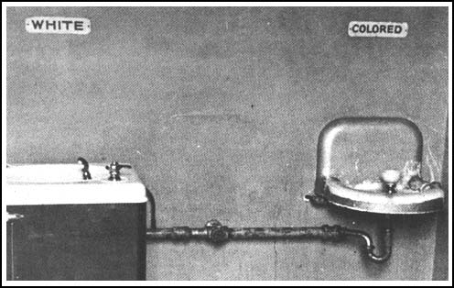

Document #2 - Rosa Parks Montgomery Bus Boycott Document #3- Lunch Counter Sit-ins (Greensboro, North Carolina)
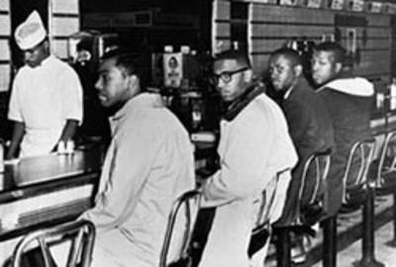
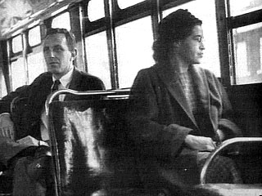

Document #4: Martin Luther King, Jr. on nonviolent civil disobedience:
“Nonviolence is a powerful and just weapon, which cuts without wounding and ennobles the man who wields it. It is a sword that heals.”
“Nonviolence means avoiding not only external physical violence but also internal violence of spirit. You not only refuse to shoot a man, but you refuse to hate him.”

Document #5 - Excerpts from the Civil Rights Act of 1964.
“All persons shall be entitled to the full and equal enjoyment of the goods, services, facilities, and privileges, advantages, and accommodations of any place of public accommodation, as defined in this section, without discrimination or segregation on the ground of race, color, religion, or national origin... [such as] any inn, hotel, motel, ... any restaurant, cafeteria, lunchroom, lunch counter, soda fountain... any motion picture house, theater, concert hall, sports arena, stadium...
All persons shall be entitled to be free, at any establishment or place, from discrimination or segregation of any kind on the ground of race, color, religion, or national origin, [even] if such discrimination or segregation is or purports to be required by any law, statute, ordinance... “
- Describe the historical circumstances of the Civil Rights Movement.

- Describe two methods used by the Civil Rights protesters to achieve equality.

- Evaluate the extent in which the Civil Rights Movement was successful in achieving its goals.

