Name: ______________________ Date: _________
Activity: “Good Reasons to Open A Checking Account” (US Bank)

Analyze the USBank infographic and following the instructions in the box:
- Read each of the 8 account features and descriptors on the infographic for
USBANK.
- Rank each feature from most important to least important. (1 to 8)
- Circle the 3 features that would be most important to you personally.

RANK THESE ACCOUNT FEATURES:
- It’s Quick and Easy
- Convenient Access To Your Cash
- Help Tracking Your Finances
- Pay Day Is Right On Time
- Online and mobile banking make your life easier
- Your money is safe
- Save on other financial needs
- Help and support when you need it.

When you are done, discuss and compare you’re the order of your ranking with your group or partner.

Share your similarities and differences.

After discussing, would you reconsider any of your initial selections? Why, why not?

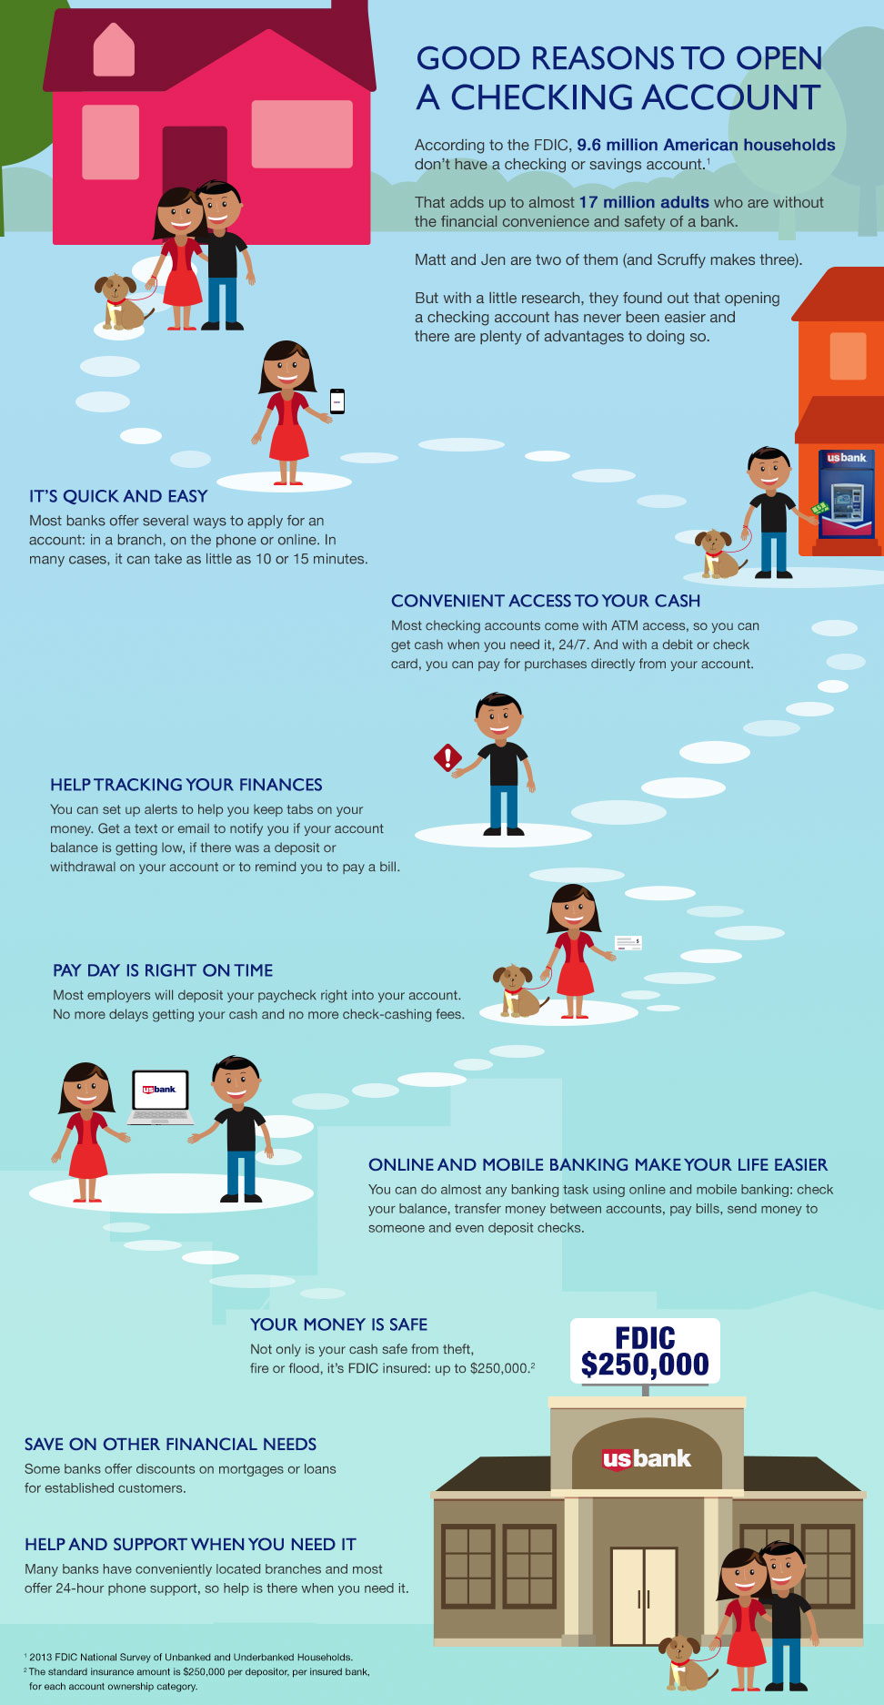
(Note: The idea for this activity comes from my friends at NGPF.org. Thank you! -RM)

